Matric No: _________________

NAPIER UNIVERSITY

SCHOOL OF COMPUTING

CO22001

DATABASE SYSTEMS

ACADEMIC SESSION: 2003-2004
EXAMINATION DIET: JANUARY

TRIMESTER: ONE

EXAMINATION DURATION: 2 HOURS

READING TIME: NONE

EXAM PAPER INFORMATION

Number of pages – TWENTY

Number of questions – FORTY

Select ONE from (a) to (e)

Answers must be inserted on the EDPAC answer sheet provided using an HB pencil.

For full instructions see next page.

EXAMINER: DR. G. RUSSELL

PLEASE READ THE FULL INSTRUCTIONS BEFORE COMMENCING WRITING

Instructions to Candidates -
Write the following details in the top of the Candidate Name section in this order:

Your surname
Your Initials

In the machine readable part of the name section, make a horizontal mark between the two brackets on the letter of your choice to enter the following details in machine readable form in this order:

Your surname
Your initials

e.g. [C] [H] [E] [S] [N] [E] [Y] [T]

In the box named Candidate Number mark in your matriculation number.

In the box named Subject Code, mark in 001

Leave the subject box blank.

At the end of the test, return your answer sheet to the invigilator.

Attempt all of the following questions. The test consists of 40 multiple choice questions.

All the questions offer five options. For each you are required to indicate which you consider the single most appropriate answer. Indicate your selection by making a mark in the row on the answer sheet corresponding to the question number. Use an HB pencil and make a mark the width of the column (A - E), which corresponds to your chosen answer. To change an answer put the mark in the new column and circle the correction.

1. | When implementing security in a DBMS, which of the following is NOT supported by the GRANT command?
  a. | Removing privileges of other people.
  b. | Providing SELECT privileges.
  c. | Providing DELETE privileges.
  d. | Supporting the devolution of access control to non-DBAs.
  e. | Changing passwords.
Mark: (1)
2. | If a system can enforce referential integrity, then this ensures that ..
  a. | a foreign key attribute in a record always refers to another record which does not contain nulls
  b. | a record is always referred to from another record
  c. | a record can never contain a null value for a foreign key attribute.
  d. | a foreign key attribute in a record always refers to another record which contains nulls
  e. | a non-null foreign key attribute always refers to another record
Mark: (1)
3. | Assume the relation R(A, B, C ,D, E) is in at least 3NF. Which of the following functional dependencies must be FALSE?
  a. | A, B -> D
  b. | C, D -> E
  c. | A, B -> C
  d. | A, C -> E
  e. | None of the above
Mark: (1)

4. | For a relation to be in third normal form, which of the following is NOT a requirement?
  a. | It must be in second normal form
  b. | Every non-key attribute is fully functionally dependent on the whole key
  c. | Every determinant is a candidate key
  d. | There must be no transitive functional dependencies
  e. | more than one of the above.
Mark: (1)
5. | The relation W is to be normalised to BCNF. Select the best resulting relations of that process.  W(a,b,c,d,e)  c -> a
  a. | W(b,c,d,e)  W1(c,a)
  b. | W(c,b,d,e)  W1(c,a)
  c. | W(a,b,c,d,e)  W1(c,a)
  d. | W(a,b,d,e)  W1(c,a)
  e. | None of the above
Mark: (1)
6. | Given the following relation and dependencies, state which normal form the relation is in.  R(p,q,r,s,t)  p,q -> r,s,t  r,s -> p,q,t  t -> s
  a. | Unnormalised
  b. | First normal form
  c. | Second normal form
  d. | Third normal form
  e. | BCNF
Mark: (1)
7. | Using the tables shown, which of the following SQL queries gives a list of departments and their employees?
    Departments
    DepNo | Depname
    1 | Computng
    2 | Electrical
    3 | Geography
    4 | History
    5 | Business
    Employees
    Empno | Empname
    1 | Gordon
    1 | Ken
    1 | Brian
    1 | Colin
    1 | George
    WorkFor
    Empno | Depno
    1 | 1
    3 | 2
    4 | 1
    3 | 3
    1 | 2
    2 | 5
  a. | SELECT depname,empname  FROM departments, workfor  WHERE departments.depno = workfor.depno  ;
  b. | SELECT depname,empname  FROM departments, employees  WHERE departments.depno = employees.empno  ;
  c. | SELECT depno,empno  FROM workfor  ;
  d. | SELECT depname,empname  FROM departments, employees, workfor  WHERE departments.depno = workfor.depno  AND workfor.empno = employees.empno  ;
  e. | None of the above.
Mark: (1)

8. | The following database contains weather measurements for a number of stations around the UK. Each station is in a region, each station records a value for rainfall in cm and sunshine in hours.  region(regionid, name)  station(stationid, rainfall, sunshine, region)  Select the SQL statement which results in a list of the average rainfall for each region:
  REGIONID | NAME
  1 | BORDERS
  2 | FIFE
  3 | LOTHIAN
  STATIONID | RAINFALL | SUNSHINE | REGION
  1 | 10 | 2 | 1
  2 | 11 | 4 | 1
  3 | 55 | 0 | 3
  4 | 23 | 1 | 3
  5 | 17 | 6 | 2
  6 | 11 | 4 | 2
  7 | 41 | 3 | 2
  a. | SELECT AVG(name) ,AVG(rainfall)  FROM region, station  WHERE regionid = station.region  GROUP BY rainfall;
  b. | SELECT name, AVG(rainfall)  FROM region, station  WHERE regionid = station.region  GROUP BY stationid;
  c. | SELECT AVG(name), rainfall  FROM region, station  WHERE regionid = station.region  GROUP BY rainfall;
  d. | SELECT AVG(rainfall)  FROM station  GROUP BY stationid;
  e. | SELECT name, AVG(rainfall)  FROM region, station  WHERE regionid = station.region  GROUP BY name;
Mark: (1)
9. | SELECT a,b FROM c,d  where c has 10 records and d has 10 records results in
  a. | A table with 0 records
  b. | A table with 10 records
  c. | A table with 100 records
  d. | A table with 1000 records
  e. | The number of records cannot be predicted.
Mark: (1)
10. | The table requirement was created using the following SQL statement:  CREATE TABLE requirement (  job INTEGER,  skill VARCHAR(50),  FOREIGN KEY job REFERENCES job(reference));  Select the true statement concerning the requirements table.
    job
    reference | employer | salary
    01 | Napier | £20000
    02 | GCHQ | £22000
    03 | Napier | £24000
    requirement
    job | skill
    01 | Unix Admin
    01 | Oracle Admin
    02 | Unix Admin
    02 | Number Theory
  a. | it cannot store a field with a NULL value for job
  b. | referential integrity checks will prevent invalid values for job
  c. | it must be created BEFORE the job table
  d. | referential integrity checks will prevent identical rows being inserted
  e. | the value 'Windows 2000 Admin' is NOT permitted for the skill attribute
Mark: (1)

11. | Continuing from the previous question.  Choose the SQL statement which will return details of the jobs of interest to a candidate with experience of Unix Administration.
  a. | SELECT * FROM job  WHERE employer = 'Napier'  OR employer = "'GCHQ';
  b. | SELECT * FROM job  WHERE skill = 'Unix Admin';
  c. | SELECT 'Unix Admin' FROM job, requirement;
  d. | SELECT * FROM job  WHERE reference='Unix Admin'  AND skill = 'Unix Admin';
  e. | SELECT * FROM job, requirement  WHERE reference=job AND skill='Unix Admin';
Mark: (1)
12. | The role of a DBA includes which of the following?
  a. | user interfaces, salary budgeting, performance monitoring.
  b. | Supporting all programming languages which might be used with a database.
  c. | Loading data, evaluating new database systems, performance monitoring
  d. | security, system testing, java programming
  e. | Installing databases, C++ programming, user support.
Mark: (1)
13. | A back-up and recovery regime should protect an organisation against:
  a. | insecure data
  b. | corrupt media
  c. | incorrect data
  d. | data validation
  e. | inconsistent data
Mark: (1)

14. | Within EER diagram techniques, which of the following could be the result of Generalising?  superclass - card(cardnumber, issuer, cardholder)  subclass - visa(expiryDate, creditLimit)  subclass - switch(issueDate, colour)
  a. | superclass - card(cardnumber, issuer, cardholder)  subclass - visa(expiryDate, creditLimit)  subclass - switch(expiryDate, issueDate, colour)
  b. | card(cardnumber, issuer, cardholder, expiryDate,  creditLimit, issueDate, colour)
  c. | subclass - card(cardnumber, issuer, cardholder)  superclass - visa(expiryDate, creditLimit)  superclass - switch(issueDate, colour)
  d. | superclass - card(cardnumber, issuer, cardholder)  subclass - visa(expiryDate, creditLimit)  subclass - switch(issueDate, colour)
  e. | subclass - card(cardnumber, issuer, cardholder)  subclass - visa(expiryDate, creditLimit)  subclass - switch(issueDate, colour)
Mark: (1)
15. | The external view of the ANSI-SPARC architecture chiefly concerns:
  a. | the way the data is actually stored
  b. | the data that users outside the company are permitted to view
  c. | the formal description of the data
  d. | the interface to other applications
  e. | the way individual users see the data
Mark: (1)
16. | In the Database Analysis Life Cycle, the "Testing and evaluation" stage
  a. | comes after "Operation" so that the normal DBMS operation can be tested.
  b. | is done before the feasibility study.
  c. | comes after "Database Design" so that the design can be tested before implementation.
  d. | is part of the "implementation and loading" stage.
  e. | is done before the "Operation" stage.
Mark: (1)
17. | In the ANSI-SPARC three level architecture, which of the following is the name of one of the levels?
  a. | extra
  b. | constructional
  c. | attribute
  d. | index
  e. | internal
Mark: (1)
18. | ER Scenario  The scenario described here is that of a book library. Books in the library can be borrowed by a borrower, and a complete history of all the books a borrower has borrowed is held in the BorrowHistory entity set. All books must have an author.  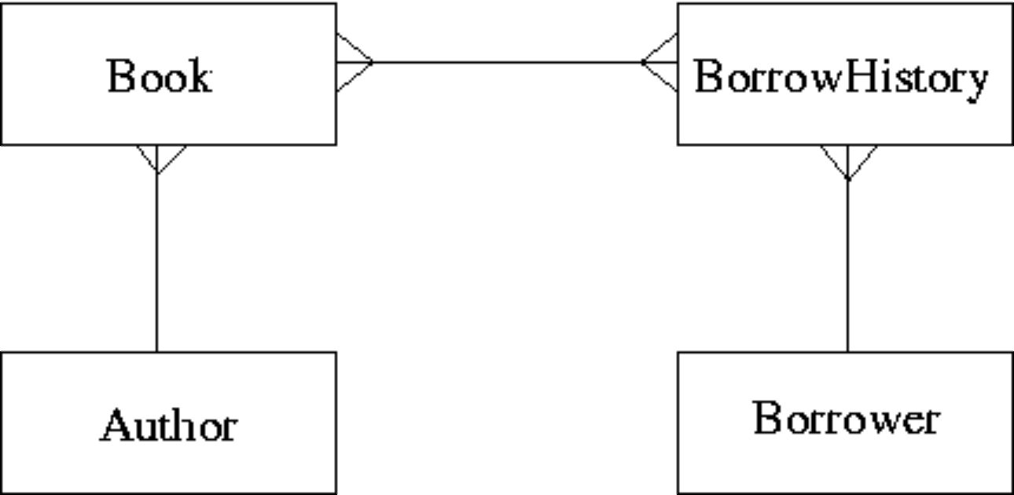  The attributes of each entity set are listed below:  Author(name,country)  Book(title,publisher)  BorrowHistory(when-borrowed,when-due-back)  Borrower(name,address,date-of-birth)  Considering the information in ER Scenario, which of the following statements is TRUE?
  a. | A book can only be borrowed once
  b. | A book can only have a single author
  c. | Many-to-many relationships should never appear in an ER diagram
  d. | A borrower must borrow multiple books.
  e. | A borrower can only borrow the same book once
Mark: (1)

19. | Given the following relation select one of the ER diagrams which could describe the relation.  R1(a,b,c,d) d is a foreign key  R2(d,x,y)  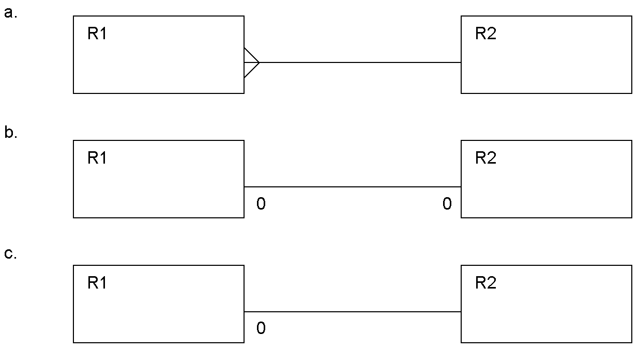
  a. | Diagram c.
  b. | Diagram b.
  c. | Diagram a.
  d. | two of the above
  e. | All three of a,b, and c.
Mark: (1)

20. | Consider the following schedule:  Which of the following shows a precedence graph for this schedule?
  Time | Transaction 1 | Transaction 2 | Transaction 3
  1 | Read(a)
  2 |  |  | Write(b)
  3 |  |  | Write(c)
  4 |  | Write(a)
  5 | Write(b)
  6 | Read(a)
  a. | 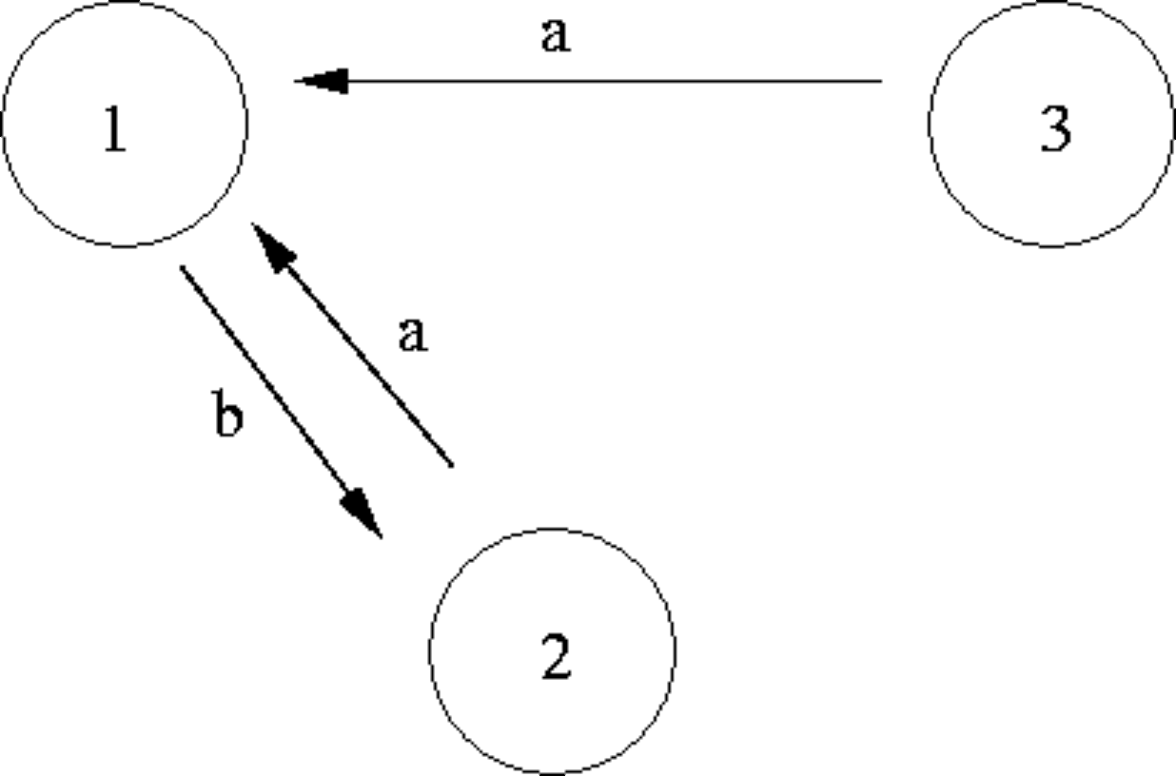
  b. | 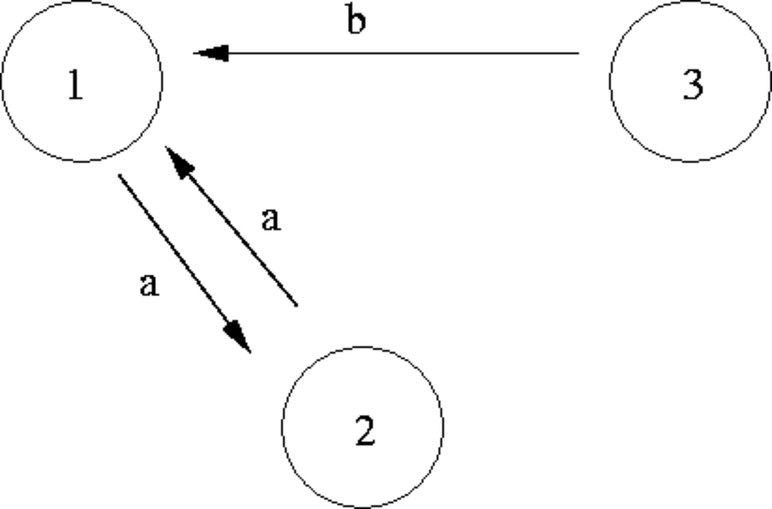
  c. | 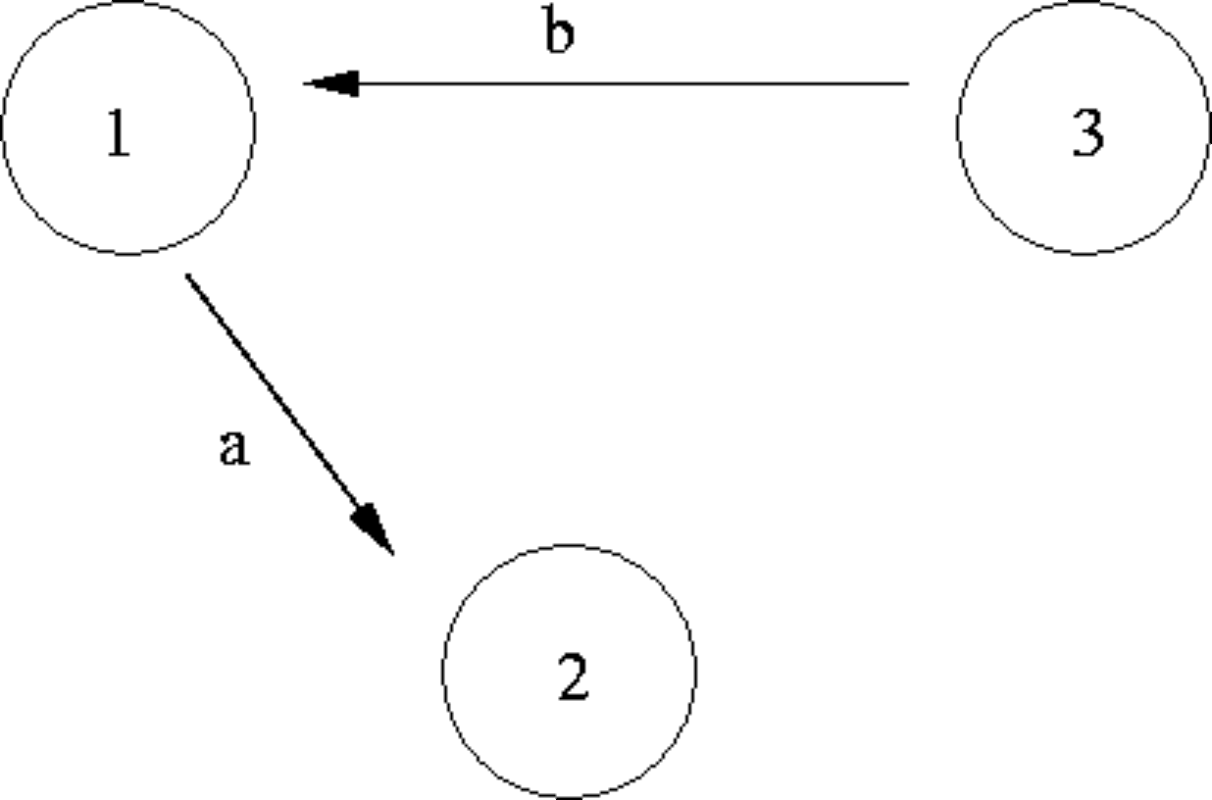
  d. | 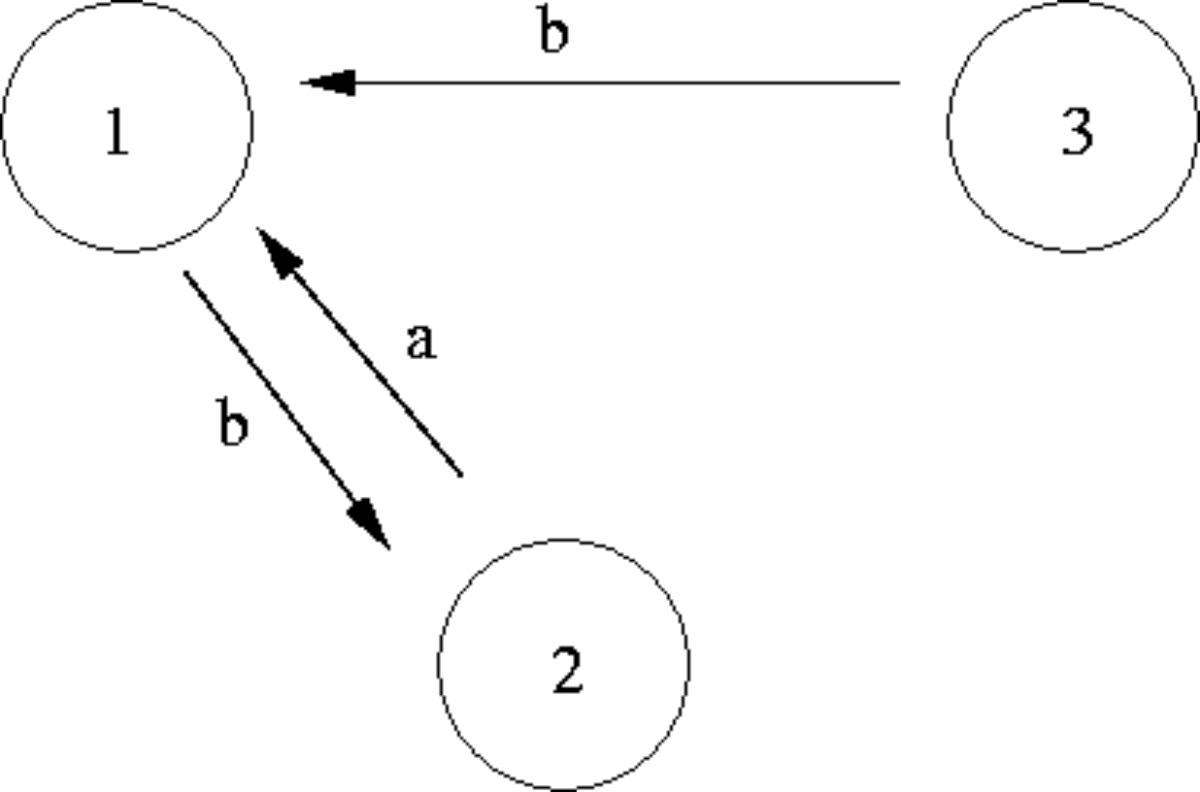
  e. | None of the above
Mark: (1)

21. | Select the problem which is demonstrated by the following schedule.
  Time | Transaction A | Transaction B
  T1 | Write(X)
  T2 |  | READ(X)
  T3 | Abort
  a. | Inconsistency Analysis
  b. | Lost Update
  c. | Uncommitted Dependency.
  d. | Incoherency Analysis
  e. | Inconsolable Update
Mark: (1)
22. | Using DEFERRED UPDATE, modifications made by a transaction which has not yet aborted or committed
  a. | are applied only to the disk
  b. | are applied only to the log file
  c. | are applied in the same way as in IMMEDIATE UPDATE.
  d. | are applied to the log file and then the disk
  e. | None of the above
Mark: (1)
23. | In transaction, cascade rollback
  a. | is a result of simultaneous transaction commits.
  b. | can occur in systems which use deferred writeback
  c. | occurs in systems which use the "waterfall" transaction management system
  d. | can occur in systems which use immediate writeback
  e. | None of the above
Mark: (1)

24. | Consider the relations P and Q above. Select the number of rows in the table resulting from the following join.  P RIGHT OUTER JOIN_{ColX = ColZ} Q
    Relation P
    ColW | ColX
    A | 4
    B | 5
    C | 6
    Relation Q
    ColY | ColZ
    B | 7
    D | 4
    C | 6
  a. | 2
  b. | 3
  c. | 4
  d. | 7
  e. | None of the above.
Mark: (1)
25. | In symbolic notation, the SELECT operator is also known as
  a. | CAP
  b. | CUP
  c. | SIGMA
  d. | OMEGA
  e. | PI
Mark: (1)

26. | The following SQL produces a list of student names where the student had an "A" grade in the exam. Select the relational algebra statement which best represents the SQL.  SELECT name  FROM student, result  WHERE student.number = result.number  AND result.grade = 'A';
  a. | σ_{name}(student |X| (π_{grade = 'A'}(result) ))
  b. | σ_{name}(student |X| (σ_{grade = 'A'}(result) ))
  c. | π_{name}(σ_{grade = 'A'}(student |X| result ))
  d. | σ_{name}(student |X|_{number=grade.number} (σ_{grade = 'A'}(result) ))
  e. | None of these.
Mark: (1)
27. | In Relational Algebra, a "tuple"
  a. | is an index.
  b. | is effectively a column of a relation.
  c. | is a set of atomic values.
  d. | is a collection of relations describing a mini-world view.
  e. | is a collection of attributes describing some real-world entity.
Mark: (1)
28. | Using SERIAL data organisation -
  a. | new records are written in primary key order
  b. | new records are written randomly
  c. | new records can only overwrite old records
  d. | new records are written in candidate key order
  e. | new records are written after the last record
Mark: (1)

29. | Indexes speed up data access. Which of the following is TRUE?
  a. | Secondary indexes must have unique keys.
  b. | Columns which are frequently modified are good candidates for indexing.
  c. | Primary indexes can have duplicate keys.
  d. | An attribute which only has a limited number of possible values will still have access performance improved using an index.
  e. | None of the above.
Mark: (1)
30. | Hash-table insertions
  a. | avoid hash-collisions by manipulating the foreign keys
  b. | become unusable if there are any hash-collisions
  c. | use primary keys to avoid hash-collisions
  d. | use balanced binary trees to allow hash-collisions
  e. | might use hash-chains to allow hash-collisions
Mark: (1)
31. | The purpose of Embedded SQL is to allow
  a. | SQL queries to be executed as part of a programming language.
  b. | programming language to be embedded in SQL
  c. | databases to be embedded in SQL
  d. | programs to be embedded in a database.
  e. | None of the above
Mark: (1)

32. | A PHP script is required to return the number of rows in the table X. Two approaches are being considered:  T1 A cursor based on the SQL statement  "SELECT * FROM X" should be used.  T2 A cursor based on the SQL statement  "SELECT COUNT(*) FROM X" should be used.
  a. | T1 and T2 are feasible however T2 is better.
  b. | T1 is feasible, T2 is not feasible.
  c. | T1 and T2 are feasible however T1 is better.
  d. | Neither T1 nor T2 are feasible
  e. | T2 is feasible, T1 is not feasible.
Mark: (1)
33. | Which one of the following techniques is sometimes used to solve integrity problems in a concurrent transaction scenario?
  a. | First-fit.
  b. | First-come first-served.
  c. | Greedy algorithms.
  d. | Two-phase locking.
  e. | Strassens's algorithm.
Mark: (1)
34. | Which of the following is a type of lock which cannot be obtained in Oracle?
  a. | Read lock
  b. | Exclusive Lock
  c. | Write Lock
  d. | Insert lock
  e. | Shared Lock
Mark: (1)

35. | With respect to Two-Phase Locking. Select the FALSE statement.
  a. | A transaction may start to release locks at any time.
  b. | The phases are "lock-acquisition" and "lock-release".
  c. | Locks are released on an ABORT.
  d. | Locks may be made at any point in the transaction schedule.
  e. | Two-Phase Locking requires key pairs.
Mark: (1)
36. | When mapping from an ER diagram into relations, some relationships may have optionality. Select the TRUE statement.
  a. | If the relationship is 1:n with one end optional, you must put the foreign key in the end which is not optional.
  b. | If the relationship is 1:n with one end optional, you must put the foreign key in the optional end
  c. | If the relationship is 1:1 with one end optional, you must subsume.
  d. | If there is both optionality and a cardinality greater than one, then you must use a composite foreign key.
  e. | If the relationship is 1:n with one end optional, you must put the foreign key in the many end.
Mark: (1)

37. | 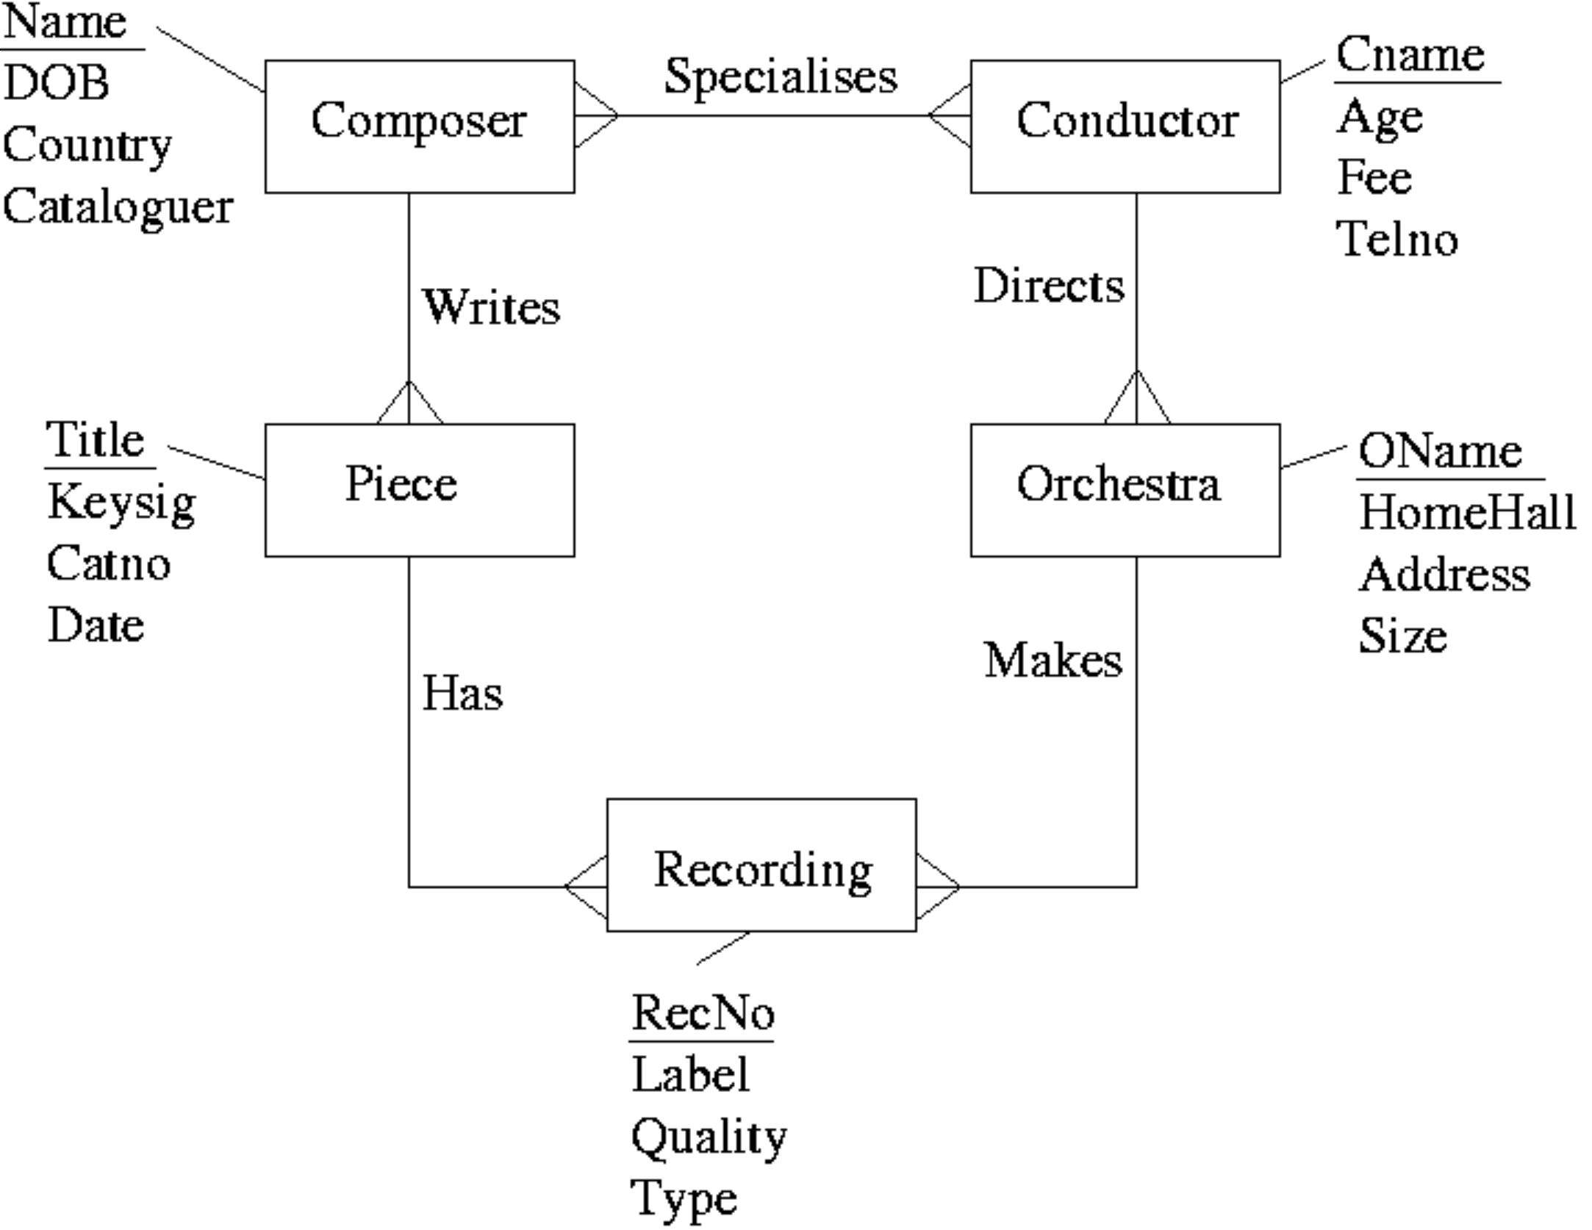  After mapping the above ERD to a relational schema, which of the following set of relations would be obtained?  Mark: (1)
  a. | Composer(Name, DOB, Country, Cataloguer)  Conductor(Cname, Age, Fee, TelNo)  Piece(Title, KeySig, CatNo, Date, Name, RecNo)  Orchestra(OName, HomeHall, Adress, Size, Cname, RecNo)  Recording(RecNo, Label, Quality, Type)  Specialises(Name, Cname)
  b. | Composer(Name, DOB, Country, Cataloguer)  Conductor(Cname, Age, Fee, TelNo)  Piece(Title, KeySig, CatNo, Date, Name)  Orchestra(OName, HomeHall, Adress, Size, Cname)  Recording(RecNo, Label, Quality, Type, Title, OName)  Specialises(Name, Cname)
  c. | Composer(Name, DOB, Country, Cataloguer, Cname)  Conductor(Cname, Age, Fee, TelNo, Name)  Piece(Title, KeySig, CatNo, Date, Name)  Orchestra(OName, HomeHall, Adress, Size, Cname)  Recording(RecNo, Label, Quality, Type, Title, OName)
  d. | Composer(Name, DOB, Country, Cataloguer)  Conductor(Cname, Age, Fee, TelNo, OName)  Piece(Title, KeySig, CatNo, Date, Name)  Orchestra(OName, HomeHall, Adress, Size)  Recording(RecNo, Label, Quality, Type, Title, OName)  Specialises(Name, Cname)
  e. | None of the above.

38. | Select the TRUE statement.
  a. | For entity integrity, all primary keys should be null or unique.
  b. | For referential integrity, all foreign keys should equal a primary key in another table.
  c. | For entity integrity, all foreign keys should be null.
  d. | For referential integrity, all primary keys should be non null.
  e. | For referential integrity, each foreign key should be null or equal to a primary key in another table.
Mark: (1)
39. | Aborting a transaction
  a. | Removes changes made in a transaction after it has committed.
  b. | Is only possible in Microsoft Access
  c. | Deletes the database for security reasons
  d. | Removes changes made so far in the current transaction.
  e. | Results in deadlock
Mark: (1)
40. | A database can be left in an inconsistent state due to
  a. | Inaccurate data is entered into the database.
  b. | A transaction fails and its changes are applied to the database.
  c. | Deadlock
  d. | Roll-forward after a failure.
  e. | Transactions being aborted.
Mark: (1)
Total marks [40]

END OF PAPER

