Matric No: _________________

NAPIER UNIVERSITY

SCHOOL OF COMPUTING

CO22001

DATABASE SYSTEMS (MALAYSIA)

ACADEMIC SESSION: 2003-2004
EXAMINATION DIET: NOVEMBER 2004

EXAMINATION DURATION: 2 HOURS

READING TIME: NONE

EXAM PAPER INFORMATION

Number of pages – TWENTY-THREE

Number of questions – FORTY

Select ONE from (a) to (e)

Answers must be inserted on the EDPAC answer sheet provided using an HB pencil.

For full instructions see next page.

EXAMINER: DR. G. RUSSELL

PLEASE READ THE FULL INSTRUCTIONS BEFORE COMMENCING WRITING

Instructions to Candidates -
Write the following details in the top of the Candidate Name section in this order:

Your surname
Your Initials

In the machine readable part of the name section, make a horizontal mark between the two brackets on the letter of your choice to enter the following details in machine readable form in this order:

Your surname
Your initials

e.g. [C] [H] [E] [S] [N] [E] [Y] [T]

In the box named Candidate Number mark in your matriculation number.

In the box named Subject Code, mark in 001

Leave the subject box blank.

At the end of the test, return your answer sheet to the invigilator.

Attempt all of the following questions. The test consists of 40 multiple choice questions.

All the questions offer five options. For each you are required to indicate which you consider the single most appropriate answer. Indicate your selection by making a mark in the row on the answer sheet corresponding to the question number. Use an HB pencil and make a mark the width of the column (A - E), which corresponds to your chosen answer. To change an answer put the mark in the new column and circle the correction.

1. | When implementing security in a DBMS, which of the following is NOT supported by the GRANT command.
  a. | Changing passwords.
  b. | Providing DELETE privileges.
  c. | Supporting the devolution of access control to non-DBAs.
  d. | Removing privileges of other people.
  e. | Providing SELECT privileges.
Mark: (1)
2. | If a system can enforce referential integrity, then this ensures that
  a. | a record can never contain a null value for a foreign key attribute.
  b. | a record is always referred to from another record
  c. | a foreign key attribute in a record always refers to another record which does not contain nulls
  d. | a non-null foreign key attribute always refers to another record
  e. | a foreign key attribute in a record always refers to another record which contains nulls
Mark: (1)
3. | Given the following relation and dependencies, state which normal form the relation is in.  R(p,q,r,s,t)  p,q -> r,s,t  r,s -> p,q,t  t -> s
  a. | Unnormalised
  b. | First normal form
  c. | Second normal form
  d. | Third normal form
  e. | BCNF
Mark: (1)

4. | The relation W is to be normalised to BCNF. Select the best resulting relations of that process.  W(a,b,c,d,e)  c -> a
  a. | W(b,c,d,e)  W1(c,a)
  b. | W(a,b,c,d,e)  W1(c,a)
  c. | W(c,b,d,e)  W1(c,a)
  d. | W(a,b,d,e)  W1(c,a)
  e. | None of the above
Mark: (1)

5. | A golf club proposes to hold a database about members, instead of the current paper-based card system. (Please note that understanding of golf terms and/or any particular field is not assumed or indeed necessary). The current membership cards hold the following fields:  Member Details:  Name, DOB, Category, Handicap, BufferValue, Increment,  Decrement, Home Club, Yardage, SSS  The following functional dependencies are identified:  FD1: Name, DOB => Handicap, HomeClub  FD2: DOB => Category  (i.e. Junior, Ordinary, Senior  or Veteran etc.)  FD3: Handicap => BufferValue, Increment, Decrement  (The SGU Handicap system)  FD4: Yardage => SSS  (The Standard Scratch Score -  an indication of the difficulty  of the course based on its  total length in yards.)  From this a third normal form of the relations has been produced which involves the following relations:  Member concerns each individual member  Categories concerns each type of membership  Handicap concerns each class of golfer  Yardage concerns each class of golf course  Select the appropriate description of the Handicap relation
  a. | Handicap: Name, DOB, Handicap
  b. | Handicap: BufferValue, Increment, Decrement, Handicap
  c. | Handicap: Handicap, BufferValue
  d. | Handicap: Handicap, Name, DOB
  e. | Handicap: Handicap, BufferValue, Increment, Decrement
Mark: (1)

6. | Which normalisation transformation corresponds to "Eliminating partial key dependencies"?
  a. | Unnormalised to 1NF
  b. | 1NF to 2NF
  c. | 2NF to 3NF
  d. | 3NF to BCNF
  e. | None of the above
Mark: (1)
7. | The table requirement was created using the following SQL statement:  CREATE TABLE requirement (  job INTEGER,  skill VARCHAR(50),  FOREIGN KEY job REFERENCES job(reference));  Select the true statement concerning the requirements table.
    job
    reference | employer | salary
    01 | Napier | £20000
    02 | GCHQ | £22000
    03 | Napier | £24000
    requirement
    job | skill
    01 | Unix Admin
    01 | Oracle Admin
    02 | Unix Admin
    02 | Number Theory
  a. | it must be created BEFORE the job table
  b. | the value 'Windows 2000 Admin' is NOT permitted for the skill attribute
  c. | referential integrity checks will prevent invalid values for job
  d. | it cannot store a field with a NULL value for job
  e. | referential integrity checks will prevent identical rows being inserted
Mark: (1)

8. | Continuing from the previous question.  Select the term which best describes the cardinality of the relationship between the table job to the table requirement.
  a. | one to one
  b. | some to many
  c. | many to one
  d. | many to many
  e. | one to many
Mark: (1)
9. | Continuing from the previous question  Which of the following show appropriate primary keys for the tables?
  a. | job(reference, employer, salary) requirement(job, skill)
  b. | job(reference, employer, salary) requirement(job, skill)
  c. | job(reference, employer, salary) requirement(job, skill)
  d. | job(reference, employer, salary) requirement(job, skill)
  e. | job(reference, employer, salary) requirement(job, skill)
Mark: (1)

10. | Using the SQL Scenario, what is the CARDINALITY of the relationship between the entity type departments and the entity type WorkFor?
    Departments
    DepNo | Depname
    1 | Computng
    2 | Electrical
    3 | Geography
    4 | History
    5 | Business
    Employees
    Empno | Empname
    1 | Gordon
    1 | Ken
    1 | Brian
    1 | Colin
    1 | George
    WorkFor
    Empno | Depno
    1 | 1
    3 | 2
    4 | 1
    3 | 3
    1 | 2
    2 | 5
  a. | N:1
  b. | 5
  c. | 2
  d. | M:N
  e. | 1:N
Mark: (1)

11. | Continuing from the previous question.  Using SQL Scenario 1, which of the following SQL queries gives the number of employees in each department?
  a. | SELECT depname,COUNT(*)  FROM departments,workfor  WHERE departments.depno = workfor.depno  GROUP BY depno  ;
  b. | SELECT depname,COUNT(empno)  FROM departments,workfor  WHERE departments.depno = workfor.depno  GROUP BY depname  ;
  c. | SELECT depname,COUNT(empno)  FROM departments,employees,workfor  WHERE departments.depno = workfor.depno  AND workfor.empno = employees.empno  GROUP BY depno  ;
  d. | SELECT depname,COUNT(depno)  FROM departments,employees,workfor  WHERE departments.depno = workfor.depno  AND workfor.empno = employees.empno  ;
  e. | None of the above.
Mark: (1)
12. | The role of a DBA includes which of the following topics?
  a. | Loading data, evaluating new database systems, performance monitoring
  b. | Installing databases, C++ programming, user support.
  c. | security, system testing, java programming
  d. | Supporting all programming languages which might be used with a database.
  e. | user interfaces, salary budgeting, performance monitoring.
Mark: (1)

13. | The Data Dictionary of a DBMS can be used for a variety of tasks. Which of the following is NOT ONE OF THESE?
  a. | Data analysis
  b. | Improved Documentation
  c. | Invoicing
  d. | Costing Change
  e. | Enforcement of standards
Mark: (1)
14. | In the ANSI/SPARC three level database model, the external view is best described by which one of the following options?
  a. | It is the place where the users interface to the DBMS.
  b. | It is the place where the storage structures link to the database.
  c. | It is the link between users and the storage structures.
  d. | It is dependent on the underlying DBMS product used (e.g. Oracle, DBASE).
  e. | It is not part of the model.
Mark: (1)
15. | In Enhanced ER diagrams, a subclass
  a. | may contain many superclasses.
  b. | can only exist in Chen's notation.
  c. | may contain only one superclass.
  d. | Is part of Chun's notation.
  e. | is contained in one superclass.
Mark: (1)

16. | Films Database  Consider the following database:  MOVIE(id,title,yr)  ACTOR(id,name)  CASTING(movieid,actorid)  Identify the SQL command which will return the titles of all 1959 Marilyn Monroe films.
  a. | The following SQL...  SELECT title FROM movie,casting,actor  WHERE movieid = movie.id  AND actor.id = actorid  AND name = 'Marilyn Monroe'  AND yr = 1959  ;
  b. | The following SQL...  SELECT title FROM movie,casting,actor  WHERE movieid = movie.id  AND name = 'Marilyn Monroe'  ;
  c. | The following SQL...  SELECT title FROM movie,actor  WHERE name = 'Marilyn Monroe'  AND yr = 1959  ;
  d. | The following SQL...  SELECT title FROM movie,casting,actor  WHERE movieid = movie.id  AND actor.id = actorid  AND movie.yr = casting.yr  AND name = 'Marilyn Monroe'  AND yr = 1959  ;
  e. | None of the above
Mark: (1)

17. | Which of the following is part of the ANSI/SPARC three level architecture model?
  a. | contextual
  b. | client
  c. | coaxial
  d. | contactable
  e. | conceptual
Mark: (1)
18. | Select the TRUE statement related to the following SQL:  SELECT X.a, X.b  FROM foo X, foo Y  WHERE X.b = Y.b AND Y.a='bar';
  a. | the statement is NOT valid SQL.
  b. | the result MUST include row with 'bar' in it.
  c. | a and b are both tables.
  d. | foo is an alias for X.
  e. | this is an example of a self-join.
Mark: (1)
19. | In the ANSI-SPARC three level architecture, which of the following is the name of one of the levels?
  a. | attribute
  b. | internal
  c. | constructional
  d. | extra
  e. | index
Mark: (1)
20. | 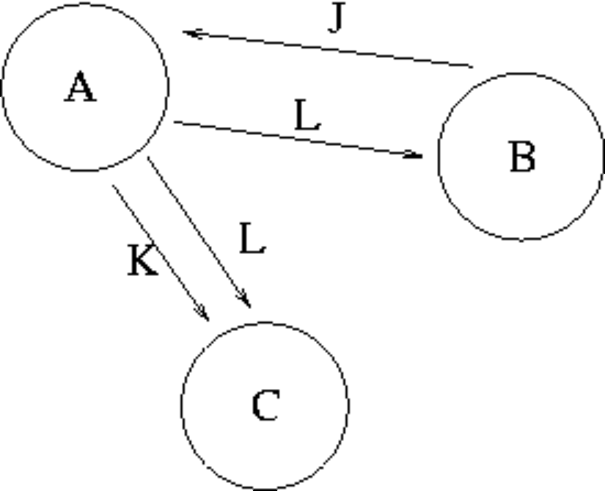  The graph in the Transaction Scenario was produced from the following schedule time:  Compare the precedence graph to the transaction schedule, and select the TRUE statement from the following:
  time | Transaction A | Transaction B | Transaction C
  1 |  | WRITE(J)
  2 | READ(J)
  3 | WRITE(K)
  4 |  |  | READ(K)
  5 | WRITE(L)
  6 |  | READ(L)
  7 |  |  | READ(L)
  8 | COMMIT
  9 |  | COMMIT
  10 |  |  | COMMIT
  a. | One or more of the arrows are pointing the wrong way
  b. | The precedence graph is accurately drawn
  c. | One or more of the loops are missing
  d. | The circles should contain the attributes, and the loops labeled with the transaction names.
  e. | Errors in BOTH loops and arrow direction
Mark: (1)

21. | Given the following transaction schedule:  Which of the following precedence graphs depicts the above scenario?
  time | TRANSACTION 1 | TRANSACTION 2 | TRANSACTION 3
  t1 | read(A)
  t2 |  | read(B) | read(B)
  t3 | read(B)
  t4 |  | write(C)
  t5 |  |  | write(B)
  t6 |  |  | read(A)
  t7 |  |  | write(A)
  t8 | write(A)
  t9 | write(C)
  a. | 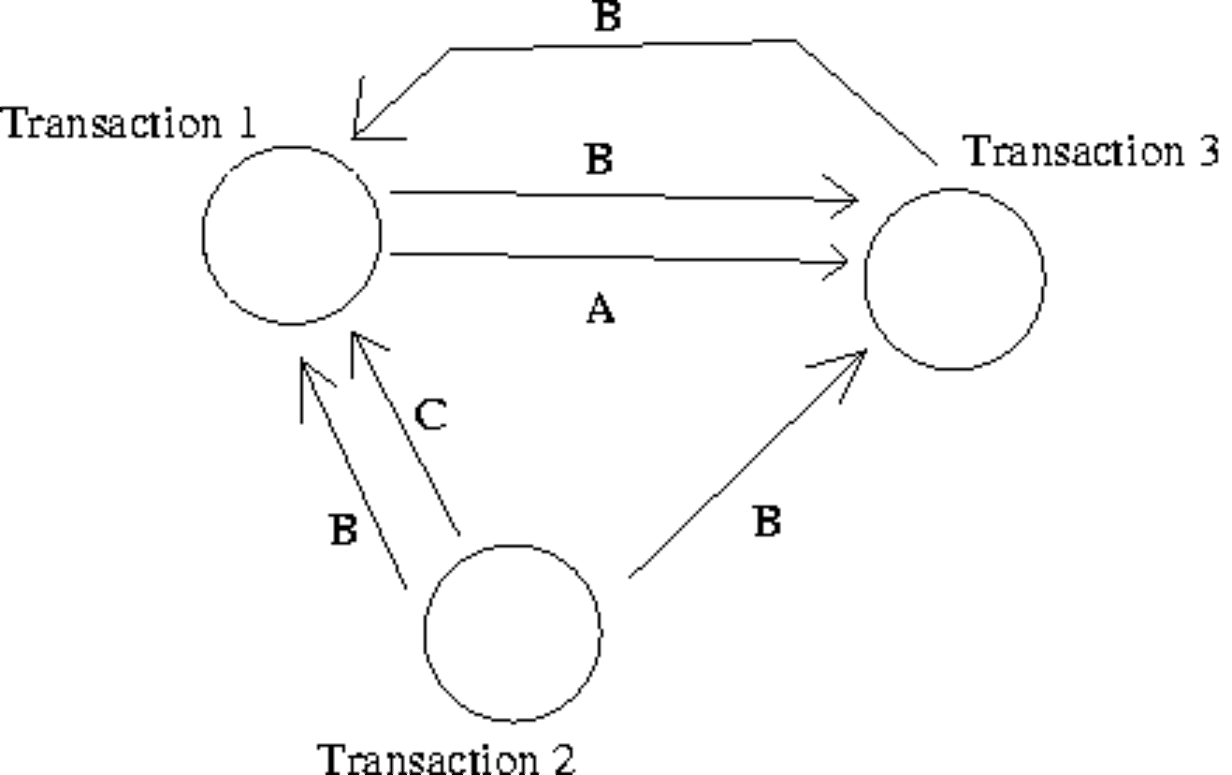
  b. | 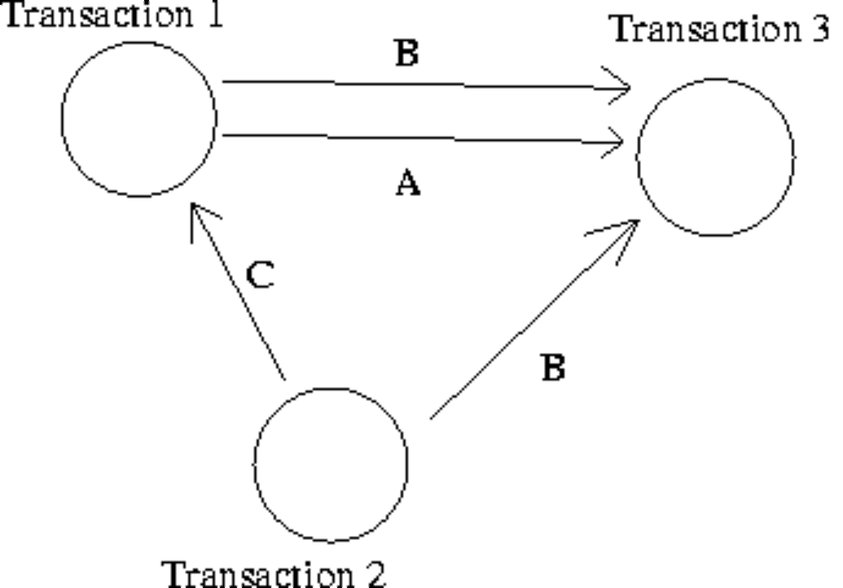
  c. | 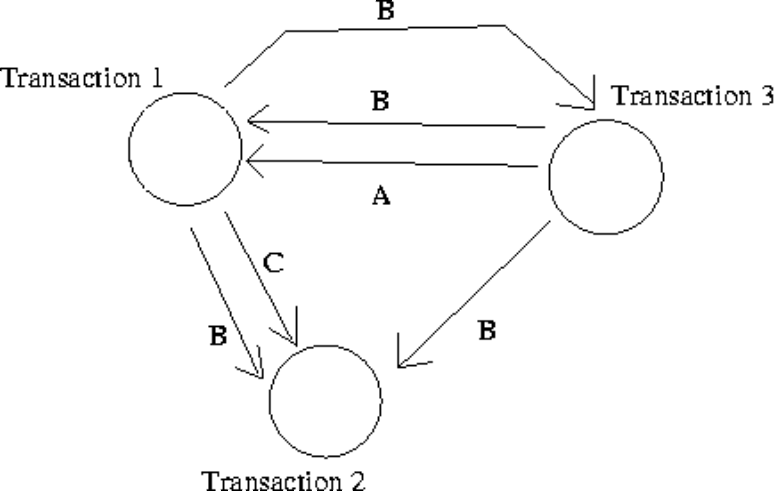
  d. | 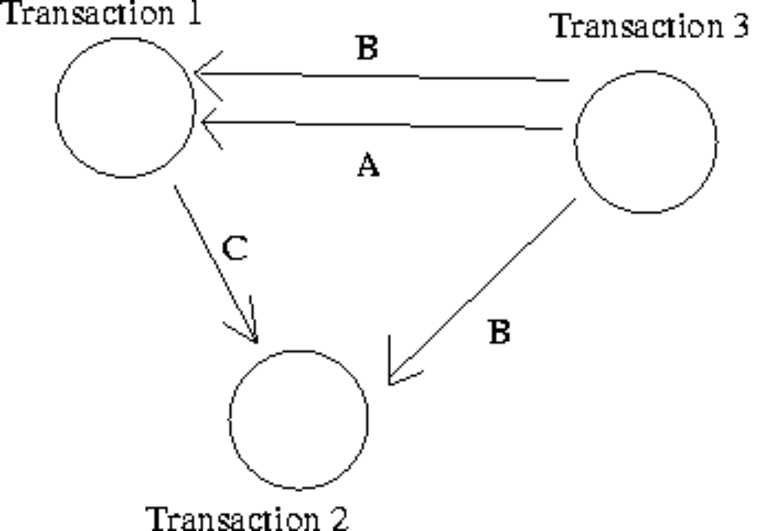
  e. | None of the above.
Mark: (1)
22. | In the acronym ACID, used to describe the important properties of transactions, what does the letter A stand for?
  a. | Atomic
  b. | Also
  c. | Action
  d. | After
  e. | None of the above
Mark: (1)
23. | Which of the following is a good example of what is meant by serialisability.
  a. | All disk access happens one after another.
  b. | The situation where the Lost Update problem exists.
  c. | All transactions happen one after another.
  d. | The situation where a cascade abort occurs.
  e. | The result of the transactions is the same as if the transactions went one after another.
Mark: (1)
24. | Consider the relations P and Q above. Select the number of rows in the table resulting from the following join.  P RIGHT OUTER JOIN_{ColX = ColZ} Q
    Relation P
    ColW | ColX
    A | 4
    B | 5
    C | 6
    Relation Q
    ColY | ColZ
    B | 7
    D | 4
    C | 6
  a. | 2
  b. | 7
  c. | 4
  d. | 3
  e. | None of the above.
Mark: (1)
25. | Consider the tables A and B shown above and select the result of  A LEFT OUTER JOIN _{col1 = col3} B
  Table A |  | Table B
    Col1 | Col2
    A | 1
    B | 3
    C | 4
    Col3 | Col4
    A | 1
    C | 4
    D | 5
    E | 3
  a.
    Col1 | Col2 | Col3 | Col4
    A | 1 | A | 1
    C | 4 | C | 4
  b.
    Col1 | Col2 | Col3 | Col4
    A | 1 | A | 1
    B | 3
    C | 4 | C | 4
     |  | D | 5
     |  | E | 3
  c.
    Col1 | Col2 | Col3 | Col4
    A | 1 | A | 1
    C | 4 | C | 4
     |  | D | 5
     |  | E | 3
  d.
    Col1 | Col2 | Col3 | Col4
    A | 1 | A | 1
    B | 3
    C | 4 | C | 4
  e. | None of the above
Mark: (1)

26. | Continuing from the previous question.  Consider the tables A and B shown above and select the result of  A JOIN _{col1 = col3} B
  a.
    Col1 | Col2 | Col3 | Col4
    A | 1 | A | 1
    B | 3
    C | 4 | C | 4
  b.
    Col1 | Col2 | Col3 | Col4
    A | 1 | A | 1
    B | 3
    C | 4 | C | 4
     |  | D | 5
     |  | E | 3
  c.
    Col1 | Col2 | Col3 | Col4
    A | 1 | A | 1
    C | 4 | C | 4
  d.
    Col1 | Col2 | Col3 | Col4
    A | 1 | A | 1
    C | 4 | C | 4
     |  | D | 5
     |  | E | 3
  e. | None of the above
Mark: (1)
27. | Relation C is a projection of relation A. Which of the following statements must be true in all cases where relation C is different from relation A?
  a. | The cardinality of C is greater than the cardinality of A
  b. | The arity of C is less than the arity of A
  c. | The arity of C is greater than the arity of A
  d. | The cardinality of C is less than the cardinality of A
  e. | None of the above
Mark: (1)
28. | Using SERIAL data organisation -
  a. | new records are written in primary key order
  b. | new records can only overwrite old records
  c. | new records are written randomly
  d. | new records are written after the last record
  e. | new records are written in candidate key order
Mark: (1)
29. | Indexes speed up data access. Select the TRUE statement.
  a. | Primary indexes can have duplicate keys.
  b. | Primary indexes may have null values.
  c. | Columns which are frequently modified are good candidates for indexing.
  d. | Secondary indexes must have unique keys.
  e. | None of the above.
Mark: (1)

30. | An athletics meeting involves several competitors who participate in a number of events. The database is intended to record who is to take part in which event and to record the outcome of each event. As results become available the winner attribute will be updated with the cid of the appropriate competitor.  Competitor(cid, name, nationality)  Event(eid, description, winner)  Competes(cid, eid)  The actual database is to contain several million competitors and nearly one hundred thousand events. The database must be indexed for producing fast results for two particular queries:  - (X) A list of the names and nationalities of the competitors for a given event where the event description is given.  - (Y) A list of event descriptions for a given competitor where the cid is given.  Which of the following is not required?
    Competitor
    cid | name | nationality
    01 | Pat | British
    02 | Hilary | British
    03 | Sven | Swedish
    04 | Pierre | French
    Event
    eid | description | winner
    01 | running
    02 | jumping
    03 | throwing
    Competes
    cid | eid
    01 | 01
    02 | 01
    03 | 02
    04 | 02
    04 | 03
  a. | An index on cid in Competes
  b. | An index on description in Events
  c. | An index on eid in Competes
  d. | An index on name in Competitors
  e. | An index on eid in Event
Mark: (1)

31. | The purpose of Embedded SQL is to allow
  a. | Programming language to be embedded in SQL
  b. | SQL queries to be executed as part of a programming language.
  c. | Databases to be embedded in SQL
  d. | Programs to be embedded in a database.
  e. | None of the above
Mark: (1)
32. | Select the TRUE statement.
  a. | SQL is embedded within a C++ program to increase the speed of the C++ program.
  b. | SQL embedded in C++ provides facilities to extract data from a database.
  c. | SQL cursors indicate the next line of code to be executed in a C++ program.
  d. | SQL is embedded to make C++ programs more efficient.
  e. | SQL is embedded within C++ to handle sequential file processing.
Mark: (1)
33. | Which of the following is a type of lock which cannot be obtained in Oracle.
  a. | Insert lock
  b. | Exclusive Lock
  c. | Read lock
  d. | Shared Lock
  e. | Write Lock
Mark: (1)

34. | Locking can be fine grained or coarse grained. Select the TRUE statement.
  a. | Course grained locking improves parallelism.
  b. | Only fine grained locking results in enforcing serializability.
  c. | Fine grained locking is more expensive to implement.
  d. | Only course grained locking results in enforcing serializability.
  e. | Fine grained locking is cheaper to implement.
Mark: (1)
35. | Select the problem that can occur due to introducing locks in a concurrent transaction scenario.
  a. | Transaction rollover
  b. | Hash key clash
  c. | Loss of integrity
  d. | Performance degradation
  e. | None of the above.
Mark: (1)
36. | When mapping EER superclasses/subclasses, which of the following options is not a valid possibility?
  a. | Use one relation for the superclass
  b. | Use a relation for the superclass and a separate relation for each of the subclasses.
  c. | Map each subclass onto separate relations
  d. | Map each subclass using class inheritance
  e. | All of the above are valid options.
Mark: (1)

37. | When mapping ER models into relations, which of the following is NOT true?
  a. | Each individual entity is mapped into a row of the corresponding relation.
  b. | Each attribute is mapped into a column of the corresponding relation.
  c. | Each m-n relationship is mapped into a new relation.
  d. | Each 1-m relationship is mapped into a new relation.
  e. | Each entity type is mapped into a relation.
Mark: (1)
38. | What is the highest normal form by which the following relation can be classified?  Delivery(Itemno,CustomerId,Quantity,CustomerTelno)  Given  Itemno,CustomerId -> Quantity,CustomerTelno  CustomerId -> CustomerTelno
  a. | 2NF
  b. | 3NF
  c. | 1NF
  d. | BCNF
  e. | Unnormalised
Mark: (1)
39. | Aborting a transaction
  a. | Removes changes made so far in the current transaction.
  b. | Results in deadlock
  c. | Deletes the database for security reasons
  d. | Is only possible in Microsoft Access
  e. | Removes changes made in a transaction after it has committed.
Mark: (1)

40. | During Rollforward, which of the following is not true?
  a. | Committed transactions in the log are reapplied.
  b. | Only once the rollforward has been completed can new transactions be performed.
  c. | Transactions which are in the log but not yet committed are restarted where they left off.
  d. | Committed transactions are reapplied in the same order as they appear in the log.
  e. | Transactions which are reapplied are reapplied to the image as it was since the last checkpoint.
Mark: (1)
Total marks [40]

END OF PAPER

