Matric No: _________________

NAPIER UNIVERSITY

SCHOOL OF COMPUTING

CO22001J

DATABASE SYSTEMS

(JAMES WATT COLLEGE)

ACADEMIC SESSION: 2003-2004

EXAMINATION DIET: JANUARY

TRIMESTER: ONE

EXAMINATION DURATION: 2 HOURS

READING TIME: NONE

EXAM PAPER INFORMATION

Number of pages – TWENTY-TWO

Number of questions – FORTY

Select ONE from (a) to (e)

Answers must be inserted on the EDPAC answer sheet provided using an HB pencil.

For full instructions see next page.

EXAMINER: DR. G. RUSSELL

PLEASE READ THE FULL INSTRUCTIONS BEFORE COMMENCING WRITING

Instructions to Candidates -
Write the following details in the top of the Candidate Name section in this order:

Your surname
Your Initials

In the machine readable part of the name section, make a horizontal mark between the two brackets on the letter of your choice to enter the following details in machine readable form in this order:

Your surname
Your initials

e.g. [C] [H] [E] [S] [N] [E] [Y] [T]

In the box named Candidate Number mark in your matriculation number.

In the box named Subject Code, mark in 001

Leave the subject box blank.

At the end of the test, return your answer sheet to the invigilator.

Attempt all of the following questions. The test consists of 40 multiple choice questions.
All the questions offer five options. For each you are required to indicate which you consider the single most appropriate answer. Indicate your selection by making a mark in the row on the answer sheet corresponding to the question number. Use an HB pencil and make a mark the width of the column (A - E), which corresponds to your chosen answer. To change an answer put the mark in the new column and circle the correction.

1. | When implementing security in a DBMS, which of the following is NOT supported by the GRANT command?
  a. | Removing privileges of other people.
  b. | Providing DELETE privileges.
  c. | Supporting the devolution of access control to non-DBAs.
  d. | Changing passwords.
  e. | Providing SELECT privileges.
Mark: (1)
2. | If a system can enforce referential integrity, then this ensures that
  a. | a foreign key attribute in a record always refers to another record which does not contain nulls
  b. | a foreign key attribute in a record always refers to another record which contains nulls
  c. | a non-null foreign key attribute always refers to another record
  d. | a record can never contain a null value for a foreign key attribute.
  e. | a record is always referred to from another record
Mark: (1)
3. | Consider the relational schema R(A,B,C,D,E) with non-key functional dependencies C,D -> E and B -> C.  Select the strongest statement that can be made about the schema R.
  a. | R is in third normal form
  b. | R is in BCNF normal form
  c. | R is in first normal form
  d. | R is in second normal form
  e. | None of the above
Mark: (1)

4. | A golf club proposes to hold a database about members, instead of the current paper-based card system. (Please note that understanding of golf terms and/or any particular field is not assumed or indeed necessary). The current membership cards hold the following fields:  Member Details:  Name, DOB, Category, Handicap, BufferValue, Increment,  Decrement, Home Club, Yardage, SSS  The following functional dependencies are identified:  FD1: Name, DOB => Handicap, HomeClub  FD2: DOB => Category  (i.e. Junior, Ordinary, Senior  or Veteran etc.)  FD3: Handicap => BufferValue, Increment, Decrement  (The SGU Handicap system)  FD4: Yardage => SSS  (The Standard Scratch Score -  an indication of the difficulty  of the course based on its  total length in yards.)  From this a third normal form of the relations has been produced which involves the following relations:  Member concerns each individual member  Categories concerns each type of membership  Handicap concerns each class of golfer  Yardage concerns each class of golf course  What type of functional dependency describes FD4?
  a. | A P.K.D.
  b. | A virtual dependency
  c. | A whole-key dependency
  d. | A transitive dependency
  e. | None of the above
Mark: (1)

5. | Which of the following is NOT an example of data redundancy?
  a. | A relationship between two entity types can be derived from another relationship.
  b. | A value in the database can be derived directly from another value.
  c. | Two attributes in the database have the same value.
  d. | A value in the database can be derived by performing a calculation on other values.
  e. | None of the above.
Mark: (1)
6. | To transform a relation from second normal form to third normal form we must remove which one of the following?
  a. | All transitive dependencies
  b. | All repeating groups
  c. | All inverse partial-key dependencies
  d. | All partial-key dependencies
  e. | None of the above
Mark: (1)
7. | SELECT a,b FROM c,d  where c has 10 records and d has 10 records results in
  a. | A table with 0 records
  b. | A table with 10 records
  c. | A table with 100 records
  d. | A table with 1000 records
  e. | The number of records cannot be predicted.
Mark: (1)

8. | The table requirement was created using the following SQL statement:  CREATE TABLE requirement (  job INTEGER,  skill VARCHAR(50),  FOREIGN KEY job REFERENCES job(reference));  Select the true statement concerning the requirements table.
    job
    reference | employer | salary
    01 | Napier | £20000
    02 | GCHQ | £22000
    03 | Napier | £24000
    requirement
    job | skill
    01 | Unix Admin
    01 | Oracle Admin
    02 | Unix Admin
    02 | Number Theory
  a. | referential integrity checks will prevent invalid values for job
  b. | it cannot store a field with a NULL value for job
  c. | it must be created BEFORE the job table
  d. | the value 'Windows 2000 Admin' is NOT permitted for the skill attribute
  e. | referential integrity checks will prevent identical rows being inserted
Mark: (1)
9. | Continuing from the previous question.  A list of jobs together with the required skills is needed. It is important that jobs such as 03, which has no skills specified, are included. Which of the following operations is most appropriate?
  a. | CARTESIAN PRODUCT
  b. | INTERSECTION
  c. | UNION
  d. | INNER JOIN
  e. | LEFT or RIGHT OUTER JOIN
Mark: (1)

10. | The standard language SQL contains features to perform which of the following functions?
  a. | specifying user passwords
  b. | specifying disk geometry
  c. | specifying frequency of backups
  d. | detecting redundant data
  e. | specifying user access rights
Mark: (1)

11. | The following database contains weather measurements for a number of stations around the UK. Each station is in a region, each station records a value for rainfall in cm and sunshine in hours.  region(regionid, name)  station(stationid, rainfall, sunshine, region)  The following SQL is intended to return the details of just the weather station in FIFE.  SELECT * FROM region, station WHERE name LIKE 'FIFE';  Select the TRUE statement
  REGIONID | NAME
  1 | BORDERS
  2 | FIFE
  3 | LOTHIAN
  STATIONID | RAINFALL | SUNSHINE | REGION
  1 | 10 | 2 | 1
  2 | 11 | 4 | 1
  3 | 55 | 0 | 3
  4 | 23 | 1 | 3
  5 | 17 | 6 | 2
  6 | 11 | 4 | 2
  7 | 41 | 3 | 2
  a. | The LIKE clause must include a wild card.
  b. | The result will include unwanted rows.
  c. | The result will include unwanted stations.
  d. | The result will be as intended.
  e. | Zero row will be returned.
Mark: (1)

12. | Continuing from the previous question.  Select the SQL statement which results in a list of the average rainfall for each region:
  a. | SELECT AVG(name), rainfall  FROM region, station  WHERE regionid = station.region  GROUP BY rainfall;
  b. | SELECT name, AVG(rainfall)  FROM region, station  WHERE regionid = station.region  GROUP BY name;
  c. | SELECT AVG(rainfall)  FROM station  GROUP BY stationid;
  d. | SELECT AVG(name) ,AVG(rainfall)  FROM region, station  WHERE regionid = station.region  GROUP BY rainfall;
  e. | SELECT name, AVG(rainfall)  FROM region, station  WHERE regionid = station.region  GROUP BY stationid;
Mark: (1)
13. | The Data Dictionary provides which of the following features?
  a. | Transaction deadlock detection.
  b. | Support for backup procedures.
  c. | Support for the SQL interface to the database.
  d. | Costings for future database changes.
  e. | None of the above.
Mark: (1)

14. | The relationship between two entity types A and B is 1:1, and the relationship is optional at the A end. Only 50% of B entities are related to an A entity. Now consider mapping these entity types into relations. Select the best statement from the following list:
  a. | B should be subsumed by A
  b. | A should be subsumed by B
  c. | A and B should be kept separate with a foreign key in both A and B.
  d. | A and B should be kept separate with the foreign key in the A relation.
  e. | A and B should be kept separate with the foreign key in the B relation.
Mark: (1)
15. | In the ANSI/SPARC three level database model, the external view is best described by which one of the following options?
  a. | It is the place where the storage structures link to the database.
  b. | It is not part of the model.
  c. | It is dependent on the underlying DBMS product used (e.g. Oracle, DBASE).
  d. | It is the link between users and the storage structures.
  e. | It is the place where the users interface to the DBMS.
Mark: (1)

16. | A timetable database is required for a University Department. Each taught event is part of a module, each event will have exactly one member of staff associated and several individual students. Each event takes place in a single weekly time slot. Each time slot has a day of the week and a time of day associated. Staff and students can have more than one event to attend.  Select the most appropriate ER diagram for the above scenario.
  a. | 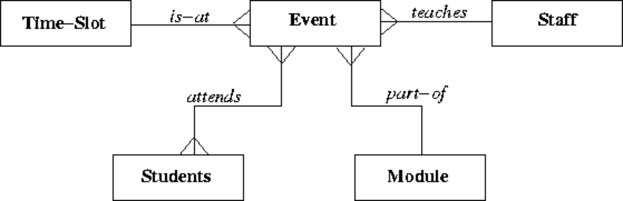
  b. | 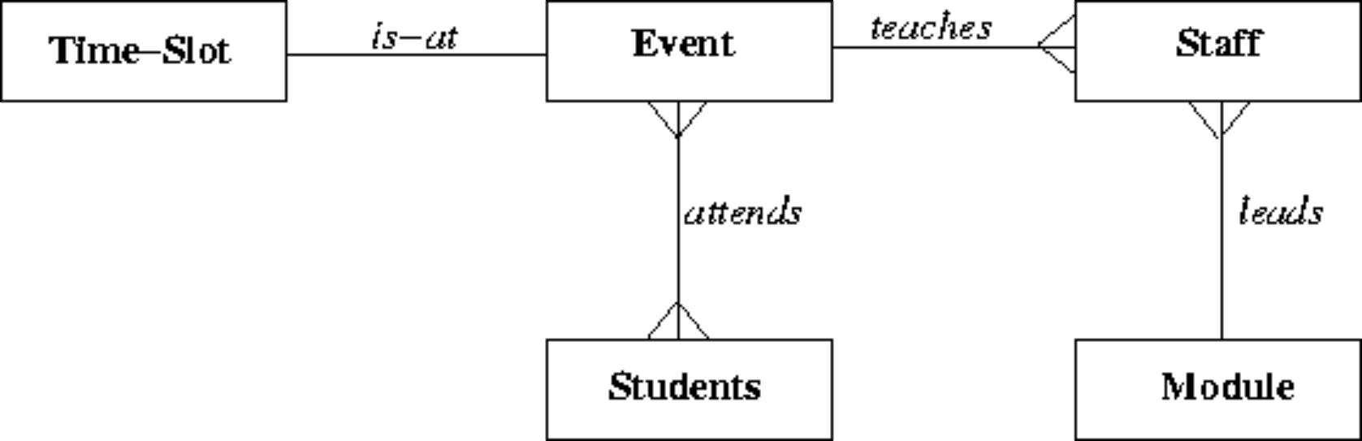
  c. | 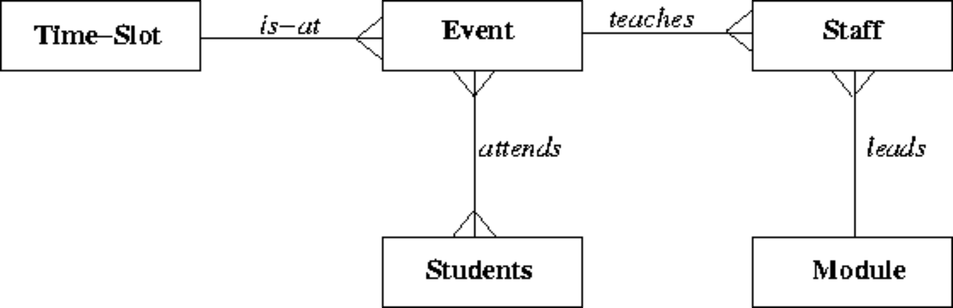
  d. | 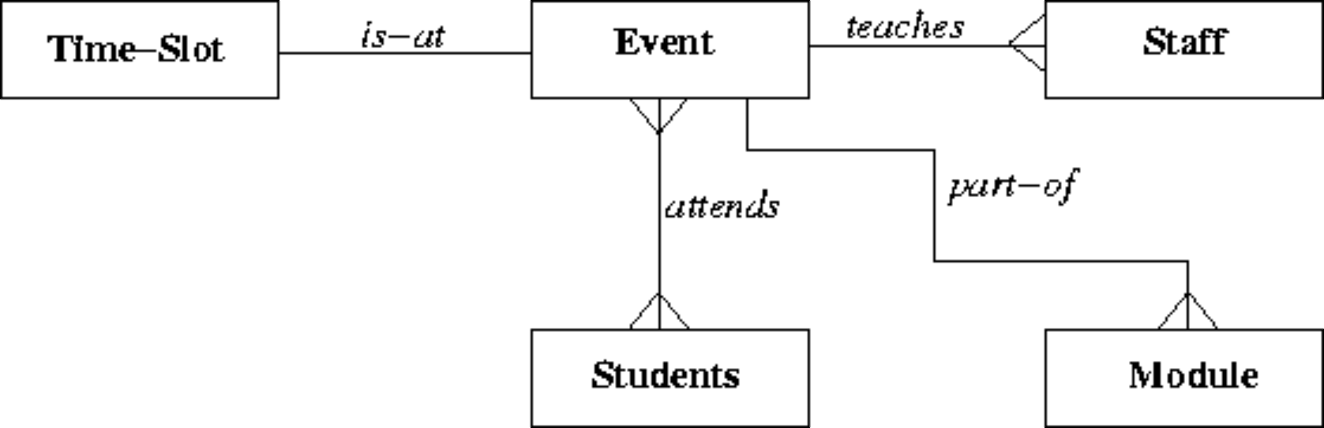
  e. | 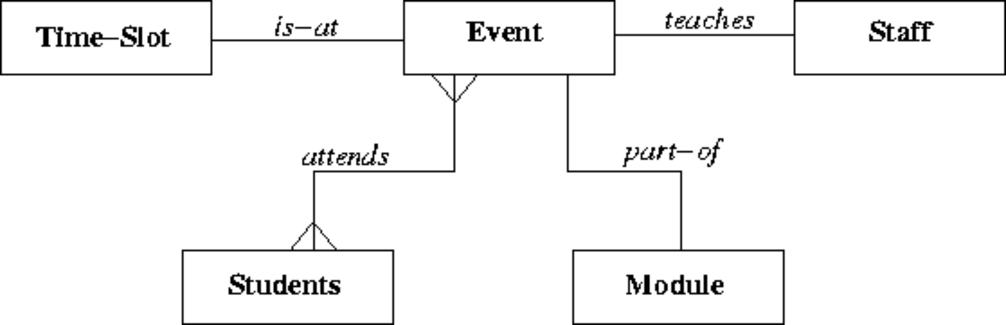
Mark: (1)
17. | ER Scenario  The scenario described here is that of a book library. Books in the library can be borrowed by a borrower, and a complete history of all the books a borrower has borrowed is held in the BorrowHistory entity set. All books must have an author.  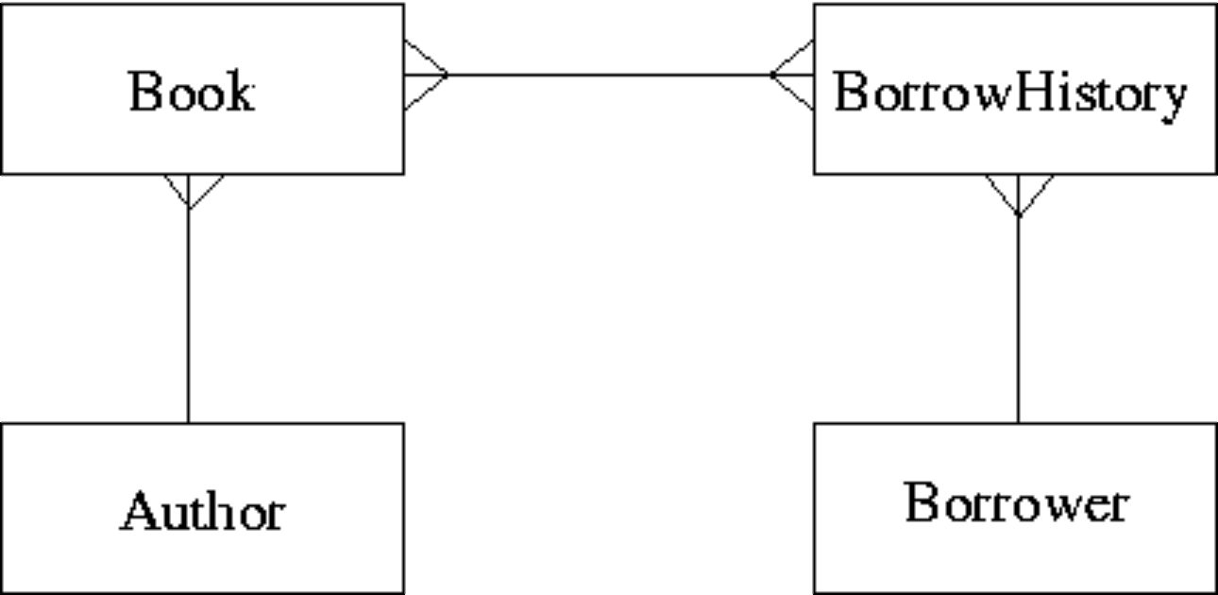  The attributes of each entity set are listed below:  Author(name,country)  Book(title,publisher)  BorrowHistory(when-borrowed,when-due-back)  Borrower(name,address,date-of-birth)  Considering the information in ER Scenario, which of the following statements is TRUE?
  a. | A book can only have a single author.
  b. | Many-to-many relationships should never appear in an ER diagram.
  c. | A borrower must borrow multiple books.
  d. | A book can only be borrowed once.
  e. | A borrower can only borrow the same book once.
Mark: (1)
18. | Consider the development process for the "Three level model". Select the statement which is most generally TRUE.
  a. | "Data Model" concerns the external users' view of the data.
  b. | "Physical Design" is used to produce an ER model.
  c. | "Physical Design" may refer to indexes.
  d. | An ER model is required prior to "Conceptual Design".
  e. | "Conceptual Design" is dependent on the target DBMS platform.
Mark: (1)

19. | In the Database Analysis Life Cycle, what are the last two steps in the cycle before it begins to repeat?
  a. | "Operation" and then "Payment"
  b. | "Implementation" and then "Training"
  c. | "Testing and Evaluation" and then "Operation"
  d. | "Operation" and then "Maintenance and Evolution"
  e. | "Operation" and then "Training"
Mark: (1)
20. | Deadlock occurs when
  a. | transactions compete for the same resource.
  b. | the DBMS cannot decide what to do next.
  c. | the user requests a cascade abort
  d. | a transaction cannot decide what to do next.
  e. | the state of a lock in the DBMS changes from live to dead.
Mark: (1)
21. | In the transaction schedule shown below for a system without concurrency control, what is the name of the error introduced?
  time | Transaction A | Transaction B
  1 |  | WRITE(A)
  2 | READ(A)
  3 |  | ABORT
  4 | A=A+3
  5 | WRITE(A)
  6 | COMMIT
  a. | Lost Update
  b. | Uncommitted Dependency
  c. | Inconsistency Analysis
  d. | Lost Dependency
  e. | Inconsistent Update
Mark: (1)
22. | 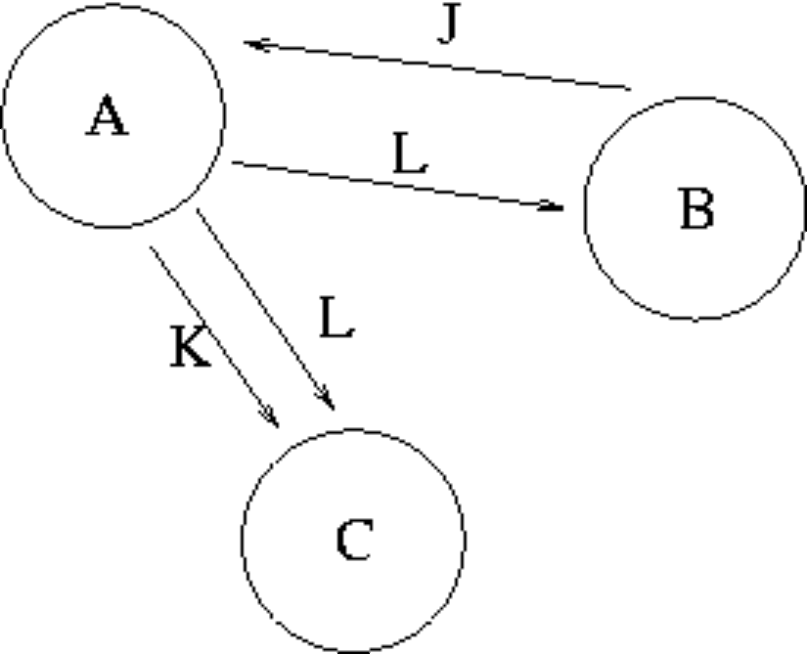  From Transaction Scenario 1, given the precedence graph, which of the following is TRUE?
  a. | Nothing as there is not enough information in the graph.
  b. | That the transaction schedule is serialisable.
  c. | That the transaction schedule could be both serialisable and unserialisable.
  d. | That the transaction schedule is unserialisable.
  e. | Nothing, as precedence graphs do not work for more than two transactions.
Mark: (1)
23. | Select the problem which is demonstrated by the following schedule.
  Time | Transaction A | Transaction B
  T1 | Write(X)
  T2 |  | READ(X)
  T3 | Abort
  a. | Inconsolable Update
  b. | Incoherency Analysis
  c. | Lost Update
  d. | Uncommitted Dependency.
  e. | Inconsistency Analysis
Mark: (1)

24. | Using the Relation Algebra Scenario, what is the cardinality of the resulting relation of:  R FULL OUTER JOIN_{R.ColA = S.ColC} S
  R |  | S
    ColA | ColB
    A | 1
    C | 4
    D | 6
    E | 6
    ColC | ColD
    C | 2
    D | 1
    G | 6
    J | 7
  a. | 6
  b. | 0
  c. | 8
  d. | 2
  e. | None of the above.
Mark: (1)

25. | Consider the relations P and Q above. Select the number of rows in the table resulting from the following join.  P RIGHT OUTER JOIN_{ColX = ColZ} Q
    Relation P
    ColW | ColX
    A | 4
    A | 5
    B | 4
    B | 5
    C | 6
    Relation Q
    ColY | ColZ
    B | 7
    D | 4
    C | 6
  a. | 2
  b. | 3
  c. | 4
  d. | 5
  e. | None of the above.
Mark: (1)
26. | The following SQL produces a list of student names where the student had an "A" grade in the exam. Select the relational algebra statement which best represents the SQL.  SELECT name  FROM student, result  WHERE student.number = result.number  AND result.grade = 'A';
  a. | σ_{name}(student |X| (π_{grade = 'A'}(result) ))
  b. | π_{name}(σ_{grade = 'A'}(student |X| result ))
  c. | σ_{name}(student |X| (σ_{grade = 'A'}(result) ))
  d. | σ_{name}(student |X|_{number=grade.number} (σ_{grade = 'A'}(result) ))
  e. | None of these.
Mark: (1)

27. | The role of a DBA includes which of the following topics?
  a. | User interfaces, salary budgeting, performance monitoring.
  b. | Supporting all programming languages which might be used with a database.
  c. | Loading data, evaluating new database systems, performance monitoring.
  d. | Installing databases, C++ programming, user support.
  e. | Security, system testing, java programming.
Mark: (1)
28. | The option of dropping a secondary index to a table is being considered. Which of the following is most likely to be a consequence of dropping the index?
  a. | Certain seek operations may be faster.
  b. | Certain updates may be slower.
  c. | Certain insertions may be faster.
  d. | More disk space may be required .
  e. | Certain foreign key relations may not be maintained.
Mark: (1)
29. | Which of the following is TRUE concerning TRANSFER TIME for hard drives?
  a. | Seek time is greater than transfer time.
  b. | Is the time to move data from the disk surface to the hard drive.
  c. | Transfer time is measured in Mbytes.
  d. | Depends on the number of files being transferred.
  e. | Must be measured as a ratio of seek time.
Mark: (1)

30. | Using SERIAL data organisation -
  a. | new records can only overwrite old records.
  b. | new records are written in primary key order.
  c. | new records are written in candidate key order.
  d. | new records are written randomly .
  e. | new records are written after the last record.
Mark: (1)
31. | Select the TRUE statement.
  a. | SQL cursors indicate the next line of code to be executed in a C++ program.
  b. | SQL is embedded within C++ to handle sequential file processing.
  c. | SQL is embedded within a C++ program to increase the speed of the C++ program.
  d. | SQL embedded in C++ provides facilities to extract data from a database.
  e. | SQL is embedded to make C++ programs more efficient.
Mark: (1)
32. | A PHP script is required to return the number of rows in the table X. Two approaches are being considered:  T1 A cursor based on the SQL statement  "SELECT * FROM X" should be used.  T2 A cursor based on the SQL statement  "SELECT COUNT(*) FROM X" should be used.
  a. | Neither T1 nor T2 are feasible.
  b. | T2 is feasible, T1 is not feasible.
  c. | T1 is feasible, T2 is not feasible.
  d. | T1 and T2 are feasible however T2 is better.
  e. | T1 and T2 are feasible however T1 is better.
Mark: (1)

33. | Which of the following is a type of lock which cannot be obtained in Oracle?
  a. | Write Lock
  b. | Read lock
  c. | Insert lock
  d. | Exclusive Lock
  e. | Shared Lock
Mark: (1)
34. | In a database with a strict locking mechanism deadlock can occur. Select the TRUE statement.
  a. | Deadlock can be avoided using a Precedence Graph.
  b. | Deadlock can be avoided using Timestamping.
  c. | Deadlock can be avoided using better primary keys.
  d. | Deadlock can be avoided using Two-Phase Locking.
  e. | None of the above.
Mark: (1)
35. | Which one of the following techniques is sometimes used to solve integrity problems in a concurrent transaction scenario?
  a. | Strassens's algorithm.
  b. | Greedy algorithms.
  c. | First-come first-served.
  d. | First-fit.
  e. | Two-phase locking.
Mark: (1)

36. | The process of combining entity types from an ER diagram into a single relation in a relational database is to
  a. | specialise
  b. | generalise
  c. | consume
  d. | assume
  e. | subsume
Mark: (1)

37. | 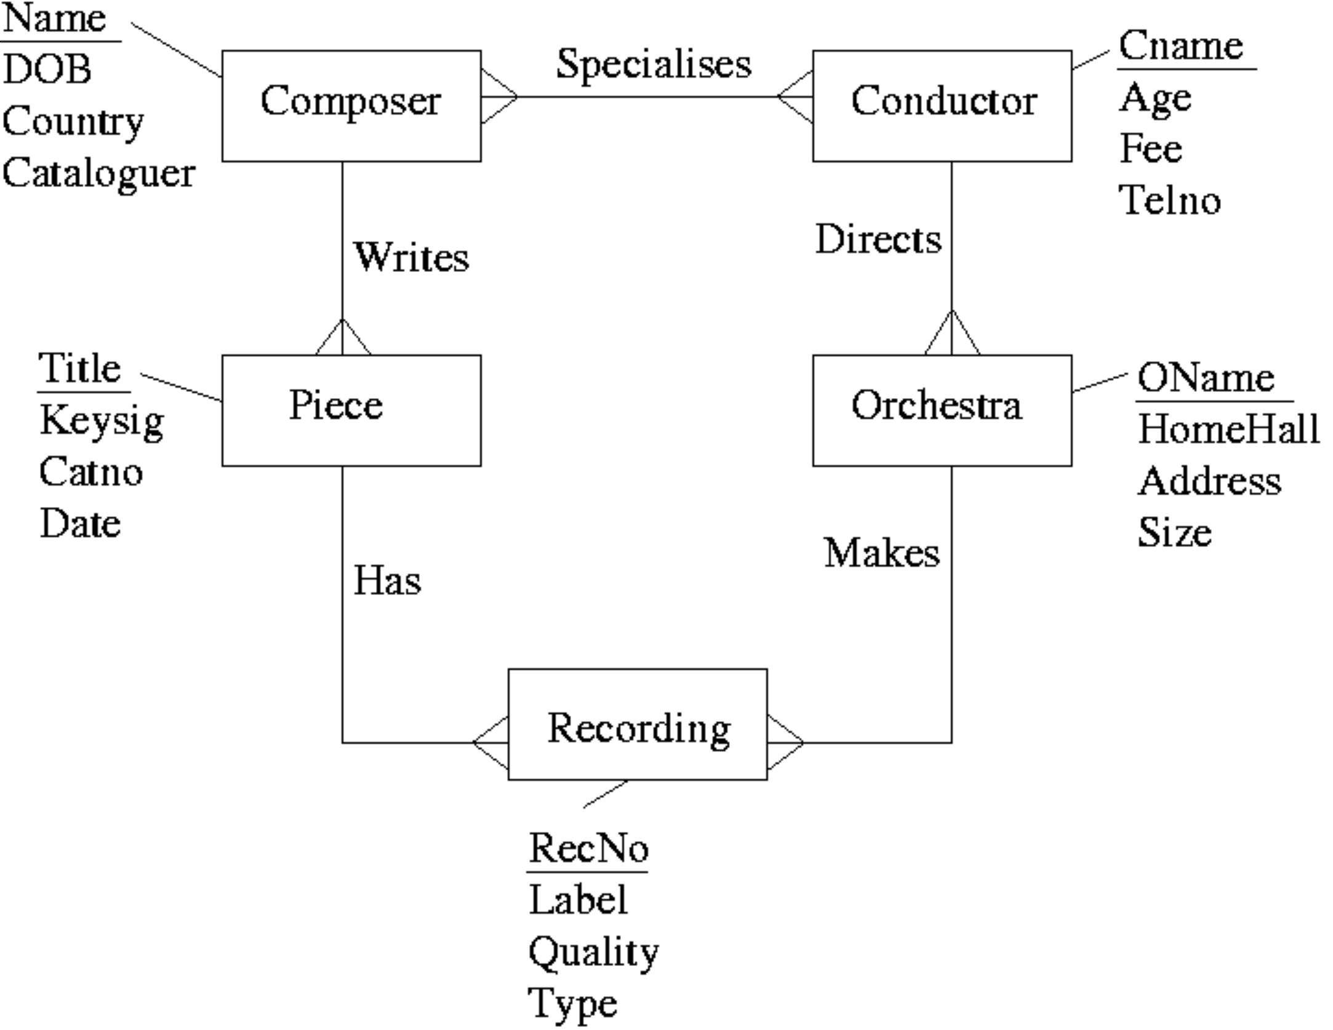  After mapping the above ERD to a relational schema, which of the following set of relations would be obtained?
  a. | Composer(Name, DOB, Country, Cataloguer)  Conductor(Cname, Age, Fee, TelNo)  Piece(Title, KeySig, CatNo, Date, Name)  Orchestra(OName, HomeHall, Adress, Size, Cname)  Recording(RecNo, Label, Quality, Type, Title, OName)  Specialises(Name, Cname)
  b. | Composer(Name, DOB, Country, Cataloguer)  Conductor(Cname, Age, Fee, TelNo)  Piece(Title, KeySig, CatNo, Date, Name, RecNo)  Orchestra(OName, HomeHall, Adress, Size, Cname, RecNo)  Recording(RecNo, Label, Quality, Type)  Specialises(Name, Cname)
  c. | Composer(Name, DOB, Country, Cataloguer)  Conductor(Cname, Age, Fee, TelNo, OName)  Piece(Title, KeySig, CatNo, Date, Name)  Orchestra(OName, HomeHall, Adress, Size)  Recording(RecNo, Label, Quality, Type, Title, OName)  Specialises(Name, Cname)
  d. | Composer(Name, DOB, Country, Cataloguer, Cname)  Conductor(Cname, Age, Fee, TelNo, Name)  Piece(Title, KeySig, CatNo, Date, Name)  Orchestra(OName, HomeHall, Adress, Size, Cname)  Recording(RecNo, Label, Quality, Type, Title, OName)
  e. | None of the above.
Mark: (1)

38. | In a relation, an instance is stored as
  a. | a Column
  b. | a Row
  c. | as a Many to many relationship
  d. | as an index
  e. | an Attribute
Mark: (1)
39. | Aborting a transaction
  a. | removes changes made so far in the current transaction.
  b. | removes changes made in a transaction after it has committed.
  c. | is only possible in Microsoft Access.
  d. | results in deadlock.
  e. | deletes the database for security reasons.
Mark: (1)
40. | A database can be left in an inconsistent state due to
  a. | inaccurate data is entered into the database.
  b. | deadlock.
  c. | roll-forward after a failure.
  d. | transactions being aborted.
  e. | a transaction fails and its changes are applied to the database.
Mark: (1)
Total marks [40]

END OF PAPER

