Matric No:
NAPIER UNIVERSITY
SCHOOL OF COMPUTING
CO22001 J
Database Systems (JAMES WATT COLLEGE)
ACADEMIC SESSION: 2004-05
EXAMINATION DIET: AUGUST
TRIMESTER: ONE
EXAM DURATION: 2 HOURS
READING TIME: NONE
EXAM PAPER INFORMATION
EXAM PAPER INFORMATION
Answer ALL questions.
Answers must be inserted on the EDPAC answer sheet provided using an HB pencil.

For full instructions see next page.
Select ONE from (a) to (e)
Number of pages – TWENTY-THREE
Number of questions – FORTY
Number of sections – ONE
EXAMINERS: John Old, Ken Chisholm, Gordon Russell, Jessie Kennedy

PLEASE READ THE FULL INSTRUCTIONS BEFORE COMMENCING WRITING

Instructions to Candidates -
Write the following details in the top of the Candidate Name section in this order:

Your surname
Your Initials

In the machine readable part of the name section, make a horizontal mark between the two brackets on the letter of your choice to enter the following details in machine readable form in this order:

Your surname
Your initials

e.g. [R] [U] [S] [S] [E] [L] [L] [G]

In the box named Candidate Number mark in your matriculation number.

In the box named Subject Code, mark in 001

Leave the subject box blank.

At the end of the test, return your answer sheet to the invigilator.

Attempt all of the following questions. The test consists of 40 multiple choice questions.

All the questions offer five options. For each you are required to indicate which you consider the single most appropriate answer. Indicate your selection by making a mark in the row on the answer sheet corresponding to the question number. Use an HB pencil and make a mark the width of the column (A - E), which corresponds to your chosen answer. To change an answer put the mark in the new column and circle the correction.

1. | If a system can enforce referential integrity, then this ensures that
  a. | a foreign key attribute in a record always refers to another record which does not contain nulls
  b. | a record is always referred to from another record
  c. | a foreign key attribute in a record always refers to another record which contains nulls
  d. | a record can never contain a null value for a foreign key attribute.
  e. | a non-null foreign key attribute always refers to another record
Mark: (1)
2. | Assume the relation R(A, B, C ,D, E) is in at least 3NF. Which of the following functional dependencies must be FALSE?
  a. | A, B -> C
  b. | A, B -> D
  c. | A, C -> E
  d. | C, D -> E
  e. | None of the above
Mark: (1)

3. | Given a database:  Customer(Cust_no,Name,Address)  Order(Order_no,Cust_no,C_Date,Completed)  Make(Order_no,Maker_no,Dress_style,Colour)  Identify the SQL command which will return the C_Date and dress_style for all orders that have completed and are made from either Red of Blue coloured materials. Consider:  SQL1:  (SELECT C_Date,Dress_style  FROM order,make  WHERE order.order_no = Make.order_no  AND completed = 'Y'  AND Colour = 'Red')  UNION  (SELECT C_Date,Dress_style  FROM order,make  WHERE order.order_no = Make.order_no  AND completed = 'Y'  AND Colour = 'Blue')  SQL2:  SELECT C_Date  FROM order,make  WHERE completed = 'Y'  AND Colour = 'Blue' OR colour = 'Red'  SQL3:  SELECT C_Date  FROM order,make  WHERE completed = 'Y'  AND (Colour = 'Blue'  OR colour = 'Red')
  a. | Just SQL1
  b. | Just SQL2
  c. | Just SQL3
  d. | Two of the three queries are correct
  e. | All of the three queries are correct
Mark: (1)

4. | Which normalisation transformation corresponds to "Eliminating partial key dependencies"?
  a. | unnormalised to 1NF
  b. | 1NF to 2NF
  c. | 2NF to 3NF
  d. | 3NF to BCNF
  e. | None of the above
Mark: (1)
5. | Select the TRUE statement which would indicate data in the database as "redundant".
  a. | The data has not yet been COMMITTED to the database
  b. | It is unique in the database
  c. | It can be derived from other data in the database.
  d. | A VIEW has the same data as a TABLE.
  e. | Secondary keys are not unique
Mark: (1)
6. | A given relation is known to be in third normal form. Select the statement which can be inferred from this:
  a. | All attributes contribute to the primary key
  b. | Each non-key attribute is determined by the primary key
  c. | Every determinant is a candidate key
  d. | Each non-key attribute determines the primary key
  e. | The relation is not in fourth normal form.
Mark: (1)

7. | The following database contains weather measurements for a number of stations around the UK.. Each station is in a region, each station records a value for rainfall in cm and sunshine in hours.  region(regionid, name)  station(stationid, rainfall, sunshine, region)  The following SQL is intended to return the details of just the weather station in FIFE.  SELECT *  FROM region, station  WHERE name LIKE 'FIFE';  Select the TRUE statement
  REGIONID | NAME
  1 | BORDERS
  2 | FIFE
  3 | LOTHIAN
  STATIONID | RAINFALL | SUNSHINE | REGION
  1 | 10 | 2 | 1
  2 | 11 | 4 | 1
  3 | 55 | 0 | 3
  4 | 23 | 1 | 3
  5 | 17 | 6 | 2
  6 | 11 | 4 | 2
  7 | 41 | 3 | 2
  a. | The LIKE clause must include a wild card.
  b. | The result will include unwanted rows.
  c. | The result will be as intended.
  d. | Zero row will be returned.
  e. | The result will include unwanted stations.
Mark: (1)

8. | SELECT a,b FROM c,d  where c has 10 records and d has 10 records results in
  a. | A table with 0 records
  b. | A table with 10 records
  c. | A table with 100 records
  d. | A table with 1000 records
  e. | The number of records cannot be predicted.
Mark: (1)
9. | Which of the following best describes the relation between ISO SQL and ORACLE's SQL*PLUS?
  a. | ORACLE SQL*PLUS may be installed on a wider range of platforms
  b. | ORACLE SQL*PLUS is faster than ISO SQL
  c. | ORACLE SQL*PLUS is a commercial product, ISO SQL is freeware.
  d. | ORACLE SQL*PLUS is an attempt to implement a superset of ISO SQL
  e. | ORACLE SQL*PLUS is the industry standard definition of ISO SQL
Mark: (1)

10. | Given the following relational database schema:  Customer(custno,name,address,telno,credit_rating)  Order(orderno,custno,data,delivery_date,total)  The following query is not well-formed SQL. Which of the following describes the main problem with the query.  select custno,name  from order,customer  where customer.custno = order.orderno and  delivery_date = '01-Jan-2001';
  a. | The keywords are in lower case
  b. | The date is incorrectly formatted
  c. | The tables are in the wrong order
  d. | The join condition is wrong
  e. | None of the above
Mark: (1)
11. | A back-up and recovery regime should protect an organisation against:
  a. | incorrect data
  b. | corrupt media
  c. | insecure data
  d. | data validation
  e. | inconsistent data
Mark: (1)
12. | The role of the database administrator includes approval of changes to:
  a. | field values
  b. | concurrency locks
  c. | user accounts
  d. | records
  e. | tuples
Mark: (1)
13. | Consider the development process for the "Three level model". Select the statement which is most generally TRUE
  a. | "Physical Design" is used to produce an ER model.
  b. | "Physical Design" may refer to indexes.
  c. | "Data Model" concerns the external users' view of the data.
  d. | An ER model is required prior to "Conceptual Design".
  e. | "Conceptual Design" is dependent on the target DBMS platform.
Mark: (1)
14. | Which of the following is offered through the use of EER (Enhanced ER) Modelling?
  a. | Confirmation
  b. | Many to many relation
  c. | Partial participation
  d. | Canonisation
  e. | Specialisation
Mark: (1)

15. | A timetable database is required for a University Department. Each taught event is part of a module, each event will have exactly one member of staff associated and several individual students. Each event takes place in a single weekly time slot. Each time slot has a day of the week and a time of day associated. Staff and students can have more than one event to attend.  Each of the weekly time slots is exactly one hour long, however we wish to represent the fact that some events take more than one hour. Which of the following does not represent a possible solution.
  a. | Each event has an attribute "start" which refers to Time-Slots and "duration" which gives the number of slots spanned
  b. | A many-to-many relation between Events and Time-Slots is established
  c. | A one-to-many relation between Events and Time-Slots is established
  d. | Each event has two attributes "first" and "last" each of which refer to Time-Slots
  e. | Each event has an attribute "start" which refers to Time-Slots and "duration" which gives the length of the event in minutes
Mark: (1)
16. | When following the Database Analysis Life Cycle
  a. | You first design the database and then write the specification
  b. | You test the database before loading in the user data
  c. | Operation follows directly after Implementation.
  d. | User training is performed as part of evolution.
  e. | Evaluation is directly after Loading.
Mark: (1)

17. | Select the term which best describes the cardinality of the relationship between the table job to the table requirement.
    job
    reference | employer | salary
    01 | Napier | £20000
    02 | GCHQ | £22000
    03 | Napier | £24000
    requirement
    job | skill
    01 | Unix Admin
    01 | Oracle Admin
    02 | Unix Admin
    02 | Number Theory
  a. | many to many
  b. | one to many
  c. | one to one
  d. | some to many
  e. | many to one
Mark: (1)
18. | Within EER diagram techniques, which of the following could be the result of Generalising  superclass - card(cardnumber, issuer, cardholder)  subclass - visa(expiryDate, creditLimit)  subclass - switch(issueDate, colour)
  a. | card(cardnumber, issuer, cardholder, expiryDate,  creditLimit, issueDate, colour)
  b. | superclass - card(cardnumber, issuer, cardholder)  subclass - visa(expiryDate, creditLimit)  subclass - switch(issueDate, colour)
  c. | superclass - card(cardnumber, issuer, cardholder)  subclass - visa(expiryDate, creditLimit)  subclass - switch(expiryDate, issueDate, colour)
  d. | subclass - card(cardnumber, issuer, cardholder)  subclass - visa(expiryDate, creditLimit)  subclass - switch(issueDate, colour)
  e. | subclass - card(cardnumber, issuer, cardholder)  superclass - visa(expiryDate, creditLimit)  superclass - switch(issueDate, colour)
Mark: (1)

19. | In the ANSI-SPARC three level architecture, which of the following is the name of one of the levels.
  a. | constructional
  b. | attribute
  c. | internal
  d. | index
  e. | extra
Mark: (1)

20. | ER Scenario  The scenario described here is that of a book library. Books in the library can be borrowed by a borrower, and a complete history of all the books a borrower has borrowed is held in the BorrowHistory entity set. All books must have an author.  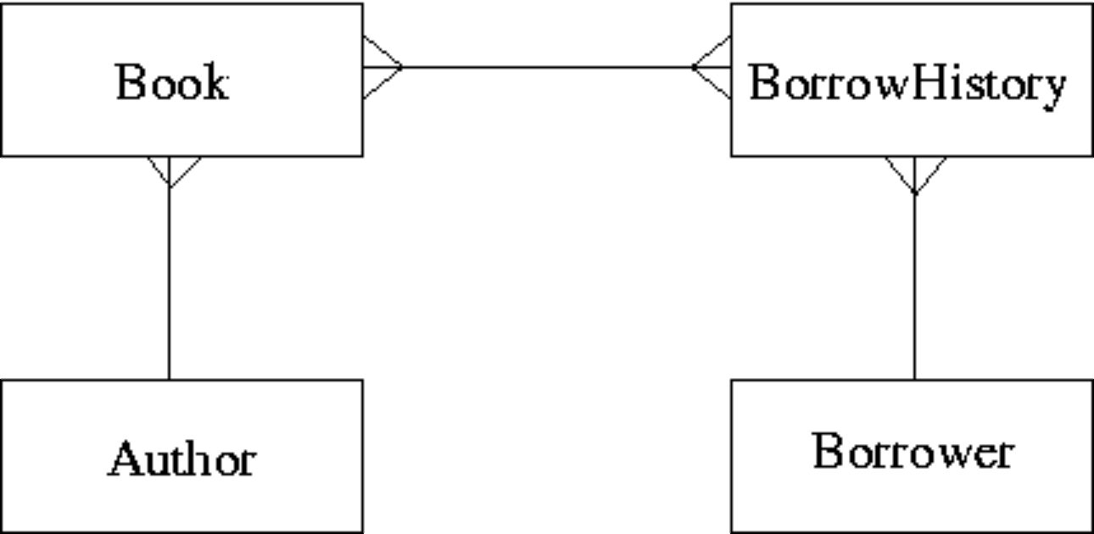  The attributes of each entity set are listed below:  Author(name,country)  Book(title,publisher)  BorrowHistory(when-borrowed,when-due-back)  Borrower(name,address,date-of-birth)  Considering the information in ER Scenario, which of the following statements is TRUE?
  a. | Many-to-many relationships should never appear in an ER diagram
  b. | A borrower can only borrow the same book once
  c. | A book can only be borrowed once
  d. | A book can only have a single author
  e. | A borrower must borrow multiple books.
Mark: (1)

21. | Given the following relation select which of the ER diagrams could describe the relation.  R1(a,b,c,d) d is a foreign key  R2(d,x,y)  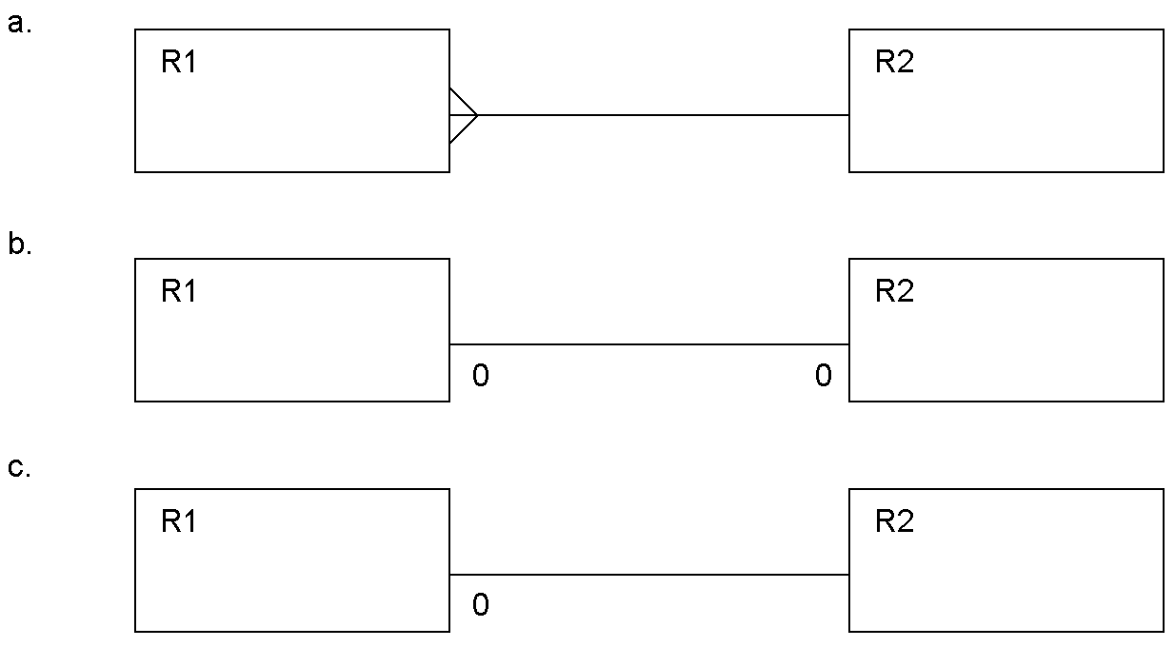
  a. | Diagram b.
  b. | Diagram c.
  c. | Diagram a.
  d. | two of the above
  e. | All three of a,b, and c.
Mark: (1)

22. | 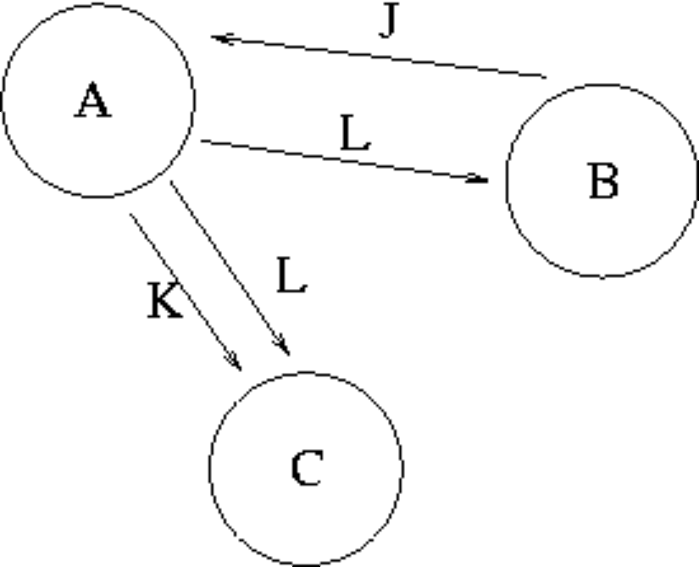  The graph in the Transaction Scenario was produced from the following schedule. time  Compare the precedence graph to the transaction schedule, and select the TRUE statement from the following:
  time | Transaction A | Transaction B | Transaction C
  1 |  | WRITE(J)
  2 | READ(J)
  3 | WRITE(K)
  4 |  |  | READ(K)
  5 | WRITE(L)
  6 |  | READ(L)
  7 |  |  | READ(L)
  8 | COMMIT
  9 |  | COMMIT
  10 |  |  | COMMIT
  a. | One or more of the loops are missing
  b. | One or more of the arrows are pointing the wrong way
  c. | Errors in BOTH loops and arrow direction
  d. | The precedence graph is accurately drawn
  e. | The circles should contain the attributes, and the loops labeled with the transaction names.
Mark: (1)

23. | Given the following transaction schedule:  Which of the following precedence graphs depicts the above scerario?
  time | TRANSACTION 1 | TRANSACTION 2 | TRANSACTION 3
  t1 | read(A)
  t2 |  | read(B) | read(B)
  t3 | read(B)
  t4 |  | write(C)
  t5 |  |  | write(B)
  t6 |  |  | read(A)
  t7 |  |  | write(A)
  t8 | write(A)
  t9 | write(C)
  a. | 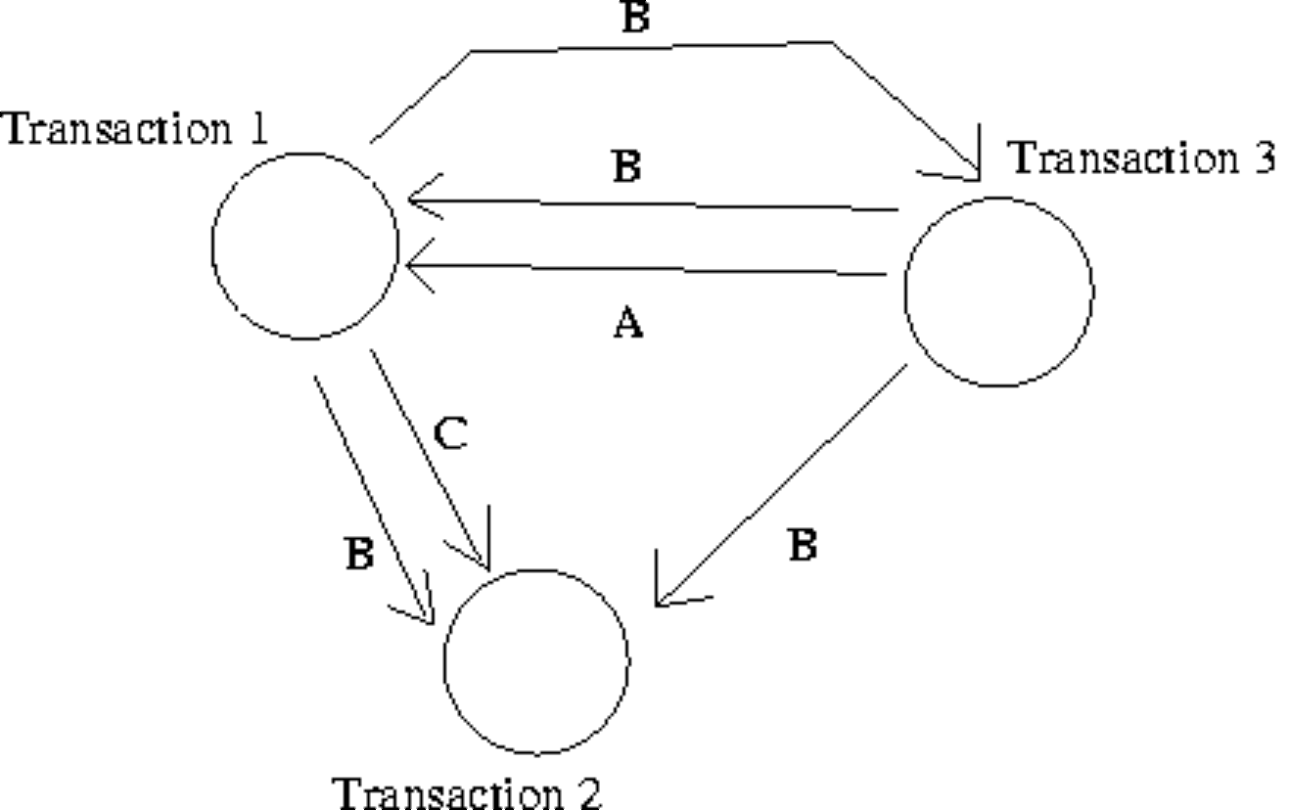
  b. | 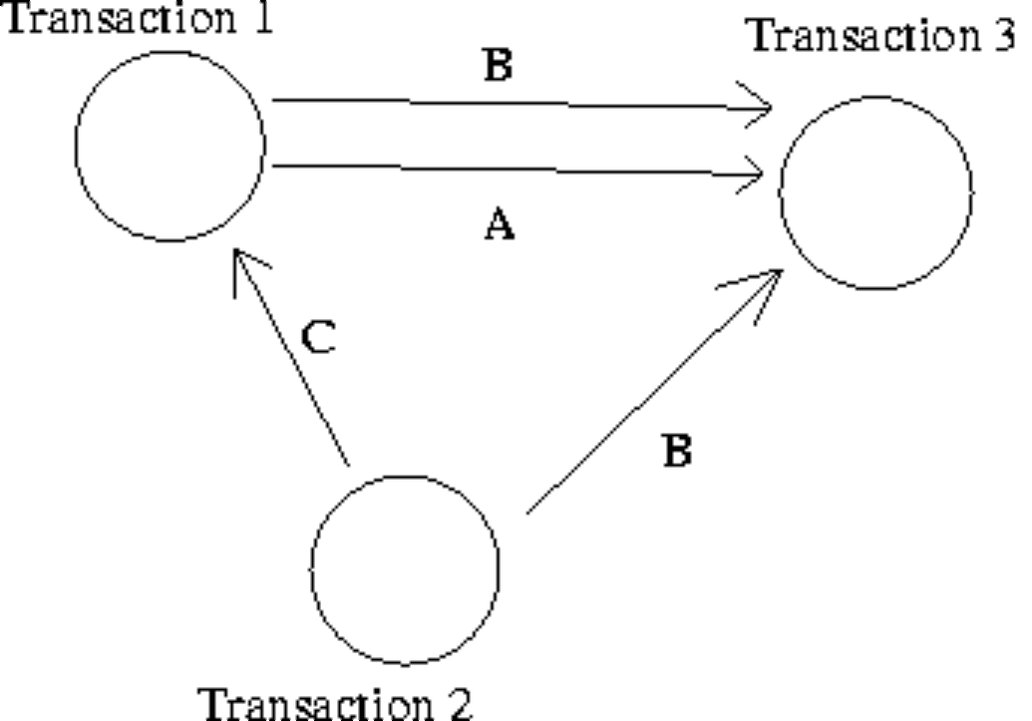
  c. | 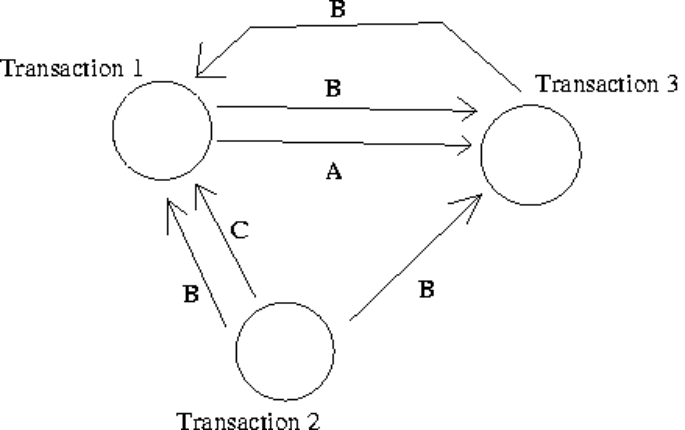
  d. | 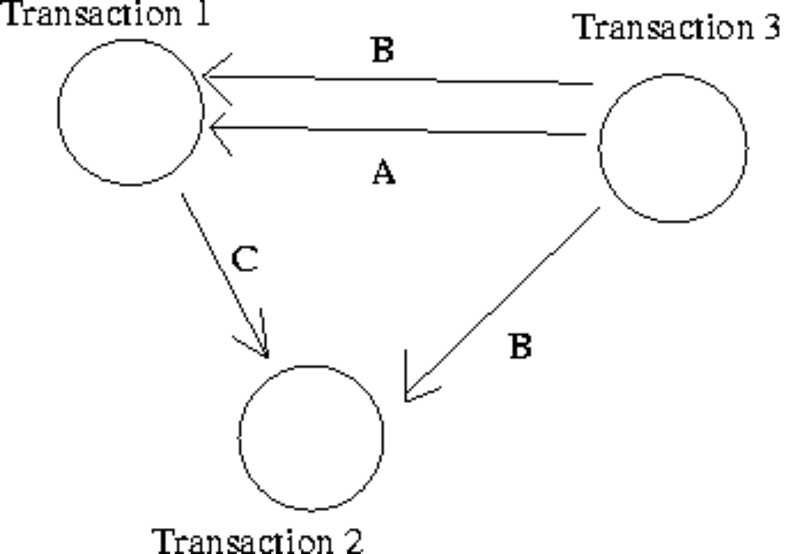
  e. | None of the above.
Mark: (1)
24. | In the transaction schedule shown below for a system without concurrency control, what is the name of the error introduced?
  time | Transaction A | Transaction B
  1 |  | WRITE(A)
  2 | READ(A)
  3 |  | ABORT
  4 | A=A+3
  5 | WRITE(A)
  6 | COMMIT
  a. | Inconsistency Analysis
  b. | Inconsistent Update
  c. | Lost Update
  d. | Uncommitted Dependency
  e. | Lost Dependency
Mark: (1)
25. | Transactions are often referred to in terms of ACID. Which one of the following is not part of the term ACID.
  a. | Atomic
  b. | Isolation
  c. | Durable
  d. | Complete
  e. | More than one of the above
Mark: (1)
26. | In relational algebra, the ρ operator represents
  a. | RENAME
  b. | UNION
  c. | JOIN
  d. | SELECT
  e. | PROJECT
Mark: (1)

27. | In relational algebra, which of the options given is the relational algebra that is equivalent to the SQL shown below.  SELECT a  FROM x,y  WHERE x.a = y.b
  a. | SELECT_{a} (x JOIN _{x.a =y.b} y)
  b. | PROJECT_{a} (x SELECT _{x.a =y.b} y)
  c. | PROJECT_{a} (x JOIN _{x.a =y.b} y)
  d. | SELECT_{a} (x PROJECT _{x.a =y.b} y)
  e. | None of the above
Mark: (1)
28. | Using SERIAL data organisation -
  a. | new records can only overwrite old records
  b. | new records are written in candidate key order
  c. | new records are written after the last record
  d. | new records are written in primary key order
  e. | new records are written randomly
Mark: (1)
29. | Hash-table insertions
  a. | avoid hash-collisions by manipulating the foreign keys
  b. | use balanced binary trees to allow hash-collisions
  c. | might use hash-chains to allow hash-collisions
  d. | become unusable if there are any hash-collisions
  e. | use primary keys to avoid hash-collisions
Mark: (1)

30. | Which of the following is always TRUE about indexing.
  a. | secondary indexing must also be based on unique secondary keys.
  b. | indexing always speeds up table access
  c. | Widely varying fields are good indexing candidates.
  d. | Primary indexing can handle duplicate keys.
  e. | You cannot query tables without building an index.
Mark: (1)
31. | The purpose of Embedded SQL is to allow
  a. | Programming language to be embedded in SQL
  b. | Programs to be embedded in a database.
  c. | SQL queries to be executed as part of a programming language.
  d. | Databases to be embedded in SQL
  e. | None of the above
Mark: (1)
32. | Select the TRUE statement.
  a. | SQL is embedded to make C++ programs more efficient.
  b. | SQL is embedded within a C++ program to increase the speed of the C++ program.
  c. | SQL embedded in C++ provides facilities to extract data from a database.
  d. | SQL cursors indicate the next line of code to be executed in a C++ program.
  e. | SQL is embedded within C++ to handle sequential file processing.
Mark: (1)

33. | Which of the following is a type of lock which cannot be obtained in Oracle.
  a. | Shared Lock
  b. | Read lock
  c. | Write Lock
  d. | Insert lock
  e. | Exclusive Lock
Mark: (1)
34. | Which one of the following techniques is sometimes used to solve integrity problems in a concurrent transaction scenario?
  a. | Greedy algorithms.
  b. | First-fit.
  c. | Two-phase locking.
  d. | First-come first-served.
  e. | Strassens's algorithm.
Mark: (1)
35. | In a relation, an instance is stored as
  a. | A Column
  b. | As an index
  c. | As a Many to many relationship
  d. | A Row
  e. | An Attribute
Mark: (1)

36. | When producing relations for the diagram shown, where almost all P entities relate to a Q entity:  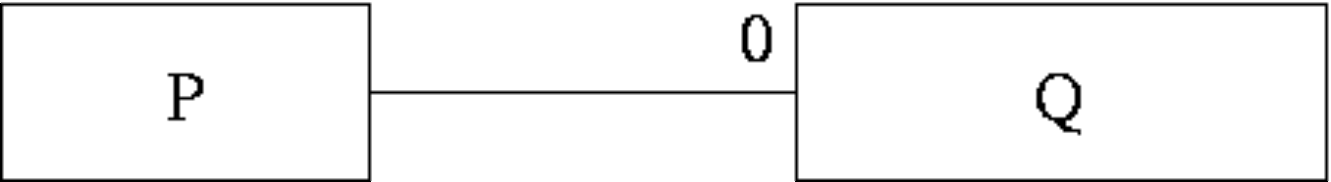  Which of the following is usually best?
  a. | This cannot be mapped into relations.
  b. | Have an intermediate table containing the primary keys from both P and Q.
  c. | it is best to keep P and Q as separate relations.
  d. | P should be subsumed into Q.
  e. | Q should be subsumed into P.
Mark: (1)
37. | Two entity types A and B are related by a 1:1 relationship which is optional at both ends. In the process of implementing A and B as relations you would
  a. | Combine A and B together into a single relation.
  b. | Use a primary key which is a composition of the primary keys of A and B.
  c. | Keep them separate and put a foreign key in both A and B.
  d. | Keep them separate and put a foreign key in one of A or B.
  e. | Combine A and B together into a single relationship.
Mark: (1)

38. | Using the scenario above, what is the CARDINALITY of the table "WorkFor"?
    Departments
    DepNo | Depname
    1 | Computng
    2 | Electrical
    3 | Geography
    4 | History
    5 | Business
    Employees
    Empno | Empname
    1 | Gordon
    1 | Ken
    1 | Brian
    1 | Colin
    1 | George
    WorkFor
    Empno | Depno
    1 | 1
    3 | 2
    4 | 1
    3 | 3
    1 | 2
    2 | 5
  a. | 12
  b. | 6
  c. | 3
  d. | 2
  e. | none of the above.
Mark: (1)
39. | During Rollforward, which of the following is NOT true
  a. | Committed transactions in the log are reapplied.
  b. | Transactions which are in the log but not yet committed are restarted where they left off.
  c. | Committed transactions are reapplied in the same order as they appear in the log.
  d. | Only once the rollforward has been completed can new transactions be performed.
  e. | Transactions which are reapplied are reapplied to the image as it was since the last checkpoint.
Mark: (1)

40. | With Immediate Update, writing to an attribute results in the DBMS
  a. | Writing the old and new attribute value to the log.
  b. | Immediately writing the change to the database stored on disk.
  c. | Immediately performing a COMMIT.
  d. | Writing the new value to the log.
  e. | Releasing concomitant locks.
Mark: (1)
Total Marks [40]

End of Paper

