Matric No:
NAPIER UNIVERSITY
SCHOOL OF COMPUTING
MODULE NO: CO22001 L
Database Systems (Lauder College)
ACADEMIC SESSION: 2004-05
EXAMINATION DIET: JANUARY
TRIMESTER: ONE
EXAM DURATION: 2 HOURS
READING TIME: NONE
EXAM PAPER INFORMATION
Answer ALL questions.
Answers must be inserted on the EDPAC answer sheet provided using an HB pencil.

For full instructions see next page.
Select ONE from (a) to (e)
Number of pages – TWENTY-FIVE
Number of questions – FORTY
Number of sections – ONE
EXAMINERS: John Old, Ken Chisholm, Gordon Russell, Jessie Kennedy

PLEASE READ THE FULL INSTRUCTIONS BEFORE COMMENCING WRITING

Instructions to Candidates -
Write the following details in the top of the Candidate Name section in this order:

Your surname
Your Initials

In the machine readable part of the name section, make a horizontal mark between the two brackets on the letter of your choice to enter the following details in machine readable form in this order:

Your surname
Your initials

e.g. [R] [U] [S] [S] [E] [L] [L] [G]

In the box named Candidate Number mark in your matriculation number.

In the box named Subject Code, mark in 001

Leave the subject box blank.

At the end of the test, return your answer sheet to the invigilator.

Attempt all of the following questions. The test consists of 40 multiple choice questions.

All the questions offer five options. For each you are required to indicate which you consider the single most appropriate answer. Indicate your selection by making a mark in the row on the answer sheet corresponding to the question number. Use an HB pencil and make a mark the width of the column (A - E), which corresponds to your chosen answer. To change an answer put the mark in the new column and circle the correction.

1. | If a system can enforce referential integrity, then this ensures that
  a. | a record is always referred to from another record
  b. | a record can never contain a null value for a foreign key attribute.
  c. | a foreign key attribute in a record always refers to another record which does not contain nulls
  d. | a foreign key attribute in a record always refers to another record which contains nulls
  e. | a non-null foreign key attribute always refers to another record
Mark: (1)

2. | A golf club proposes to hold a database about members, instead of the current paper-based card system. (Please note that understanding of golf terms and/or any particular field is not assumed or indeed necessary). The current membership cards hold the following fields:  Member Details:  Name, DOB, Category, Handicap, BufferValue, Increment,  Decrement, Home Club, Yardage, SSS  The following functional dependencies are identified:  FD1: Name, DOB => Handicap, HomeClub  FD2: DOB => Category  (i.e. Junior, Ordinary, Senior  or Veteran etc.)  FD3: Handicap => BufferValue, Increment, Decrement  (The SGU Handicap system)  FD4: Yardage => SSS  (The Standard Scratch Score -  an indication of the difficulty  of the course based on its  total length in yards.)  From this a third normal form of the relations has been produced which involves the following relations:  Member concerns each individual member  Categories concerns each type of membership  Handicap concerns each class of golfer  Yardage concerns each class of golf course  What type of functional dependency describes FD4?
  a. | A P.K.D.
  b. | A whole-key dependency
  c. | A virtual dependency
  d. | A transitive dependency
  e. | None of the above
Mark: (1)

3. | Continuing from the previous question  Select the appropriate description of the Handicap relation
  a. | Handicap: Handicap, BufferValue, Increment, Decrement
  b. | Handicap: Handicap, BufferValue
  c. | Handicap: BufferValue, Increment, Decrement, Handicap
  d. | Handicap: Name, DOB, Handicap
  e. | Handicap: Handicap, Name, DOB
Mark: (1)
4. | Select the TRUE statement which would indicate data in the database as "redundant".
  a. | It is unique in the database
  b. | It can be derived from other data in the database.
  c. | Secondary keys are not unique
  d. | A VIEW has the same data as a TABLE.
  e. | The data has not yet been COMMITTED to the database
Mark: (1)
5. | Given the following relation and dependencies, state which normal form the relation is in.  R(p,q,r,s,t)  p,q -> r,s,t  r,s -> p,q,t  t -> s
  a. | Unnormalised
  b. | First normal form
  c. | Second normal form
  d. | Third normal form
  e. | BCNF
Mark: (1)

6. | An athletics meeting involves several competitors who participate in a number of events. The database is intended to record who is to take part in which event and to record the outcome of each event. As results become available the winner attribute will be updated with the cid of the appropriate competitor.  Competitor(cid, name, nationality)  Event(eid, description, winner)  Competes(cid, eid)  Select the true statement
    Competitor
    cid | name | nationality
    01 | Pat | British
    02 | Hilary | British
    03 | Sven | Swedish
    04 | Pierre | French
    Event
    eid | description | winner
    01 | running
    02 | jumping
    03 | throwing
    Competes
    cid | eid
    01 | 01
    02 | 01
    03 | 02
    04 | 02
    04 | 03
  a. | Competes is the Cartesian product of Competitor and Event
  b. | At least one of the tables is NOT in third normal form
  c. | There is no means to represent a tie in a particular event.
  d. | The Event table has a composite key
  e. | There is no means to represent a competitor taking part in more than one event
Mark: (1)

7. | The following database contains weather measurements for a number of stations around the UK.. Each station is in a region, each station records a value for rainfall in cm and sunshine in hours.  region(regionid, name)  station(stationid, rainfall, sunshine, region)  Select the SQL statement which results in a list of the average rainfall for each region:
  REGIONID | NAME
  1 | BORDERS
  2 | FIFE
  3 | LOTHIAN
  STATIONID | RAINFALL | SUNSHINE | REGION
  1 | 10 | 2 | 1
  2 | 11 | 4 | 1
  3 | 55 | 0 | 3
  4 | 23 | 1 | 3
  5 | 17 | 6 | 2
  6 | 11 | 4 | 2
  7 | 41 | 3 | 2
  a. | SELECT name, AVG(rainfall)  FROM region, station  WHERE regionid = station.region  GROUP BY stationid;
  b. | SELECT AVG(name), rainfall  FROM region, station  WHERE regionid = station.region  GROUP BY rainfall;
  c. | SELECT name, AVG(rainfall)  FROM region, station  WHERE regionid = station.region  GROUP BY name;
  d. | SELECT AVG(rainfall)  FROM station  GROUP BY stationid;
  e. | SELECT AVG(name) ,AVG(rainfall)  FROM region, station  WHERE regionid = station.region  GROUP BY rainfall;
Mark: (1)
8. | Given the following relational database schema:  Customer(custno,name,address,telno,credit_rating)  Order(orderno,custno,data,delivery_date,total)  The following query is not well-formed SQL. Which of the following describes the main problem with the query.  select orderno,custno,date  from order  where total > 100  union  select * from order  order by delivery_date
  a. | The layout is faulty
  b. | The join condition is missing
  c. | Incompatible condition clauses
  d. | The selects cannot be unioned
  e. | Keywords are in lower case
Mark: (1)
9. | SELECT a,b FROM c,d  where c has 10 records and d has 10 records results in
  a. | A table with 0 records
  b. | A table with 10 records
  c. | A table with 100 records
  d. | A table with 1000 records
  e. | The number of records cannot be predicted.
Mark: (1)

10. | Films Database  Consider the following database:  MOVIE(id,title,yr)  ACTOR(id,name)  CASTING(movieid,actorid)  Identify the SQL command which will return the titles of all 1959 Marilyn Monroe films.
  a. | The following SQL...  SELECT title FROM movie,casting,actor  WHERE movieid = movie.id  AND name = 'Marilyn Monroe'  ;
  b. | The following SQL...  SELECT title FROM movie,casting,actor  WHERE movieid = movie.id  AND actor.id = actorid  AND movie.yr = casting.yr  AND name = 'Marilyn Monroe'  AND yr = 1959  ;
  c. | The following SQL...  SELECT title FROM movie,actor  WHERE name = 'Marilyn Monroe'  AND yr = 1959  ;
  d. | The following SQL...  SELECT title FROM movie,casting,actor  WHERE movieid = movie.id  AND actor.id = actorid  AND name = 'Marilyn Monroe'  AND yr = 1959  ;
  e. | None of the above
Mark: (1)

11. | The role of a DBA includes which of the following topics
  a. | user interfaces, salary budgeting, performance monitoring.
  b. | Loading data, evaluating new database systems, performance monitoring
  c. | security, system testing, java programming
  d. | Installing databases, C++ programming, user support.
  e. | Supporting all programming languages which might be used with a database.
Mark: (1)
12. | A back-up and recovery regime should protect an organisation against:
  a. | corrupt media
  b. | incorrect data
  c. | inconsistent data
  d. | insecure data
  e. | data validation
Mark: (1)
13. | In relational database evolution, "Conceptual Design" is the stage where we map
  a. | ER diagrams into tables
  b. | Specification into ER diagrams
  c. | ER diagrams into relations
  d. | Specification into relations
  e. | Specification into Marketing Ideas
Mark: (1)

14. | Given the following portion of an ER diagram with a n:m relationship which of the following is the correct rule for mapping it in to a relational schema?  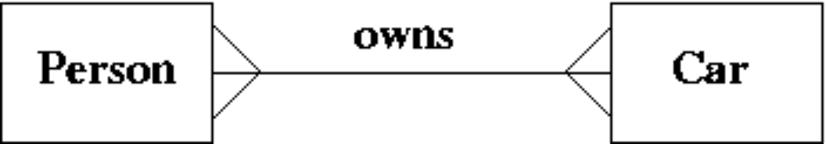
  a. | Take the primary key from person and add it to the car relation as a foreign key.
  b. | Take the primary key from car and add it to the person relation as a foreign key.
  c. | Subsume one of the relations into the other.
  d. | All of the above will work.
  e. | Take the primary key from both car and person and put them into a new relation called "owns".
Mark: (1)
15. | In the ANSI/SPARC three level database model, the external view is best described by which one of the following options:
  a. | It is the link between users and the storage structures.
  b. | It is the place where the storage structures link to the database.
  c. | It is not part of the model.
  d. | It is dependent on the underlying DBMS product used (e.g. Oracle, DBASE).
  e. | It is the place where the users interface to the DBMS.
Mark: (1)

16. | Given the following relation select which of the ER diagrams could describe the relation.  R1(a,b,c,d) d is a foreign key  R2(d,x,y)  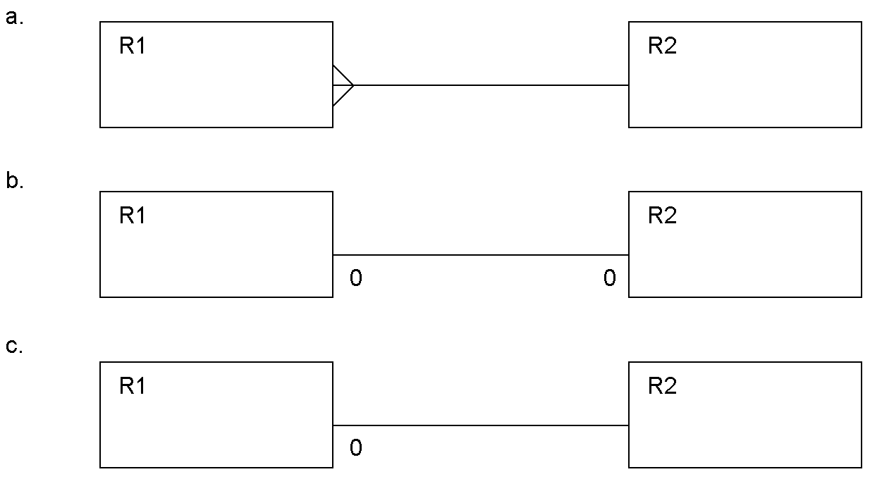
  a. | Diagram c.
  b. | Diagram b.
  c. | Diagram a.
  d. | two of the above
  e. | All three of a,b, and c.
Mark: (1)

17. | Given the following portion of an ER diagram with a 1:1 relationship which of the following is the correct rule for mapping it in to a relational schema?  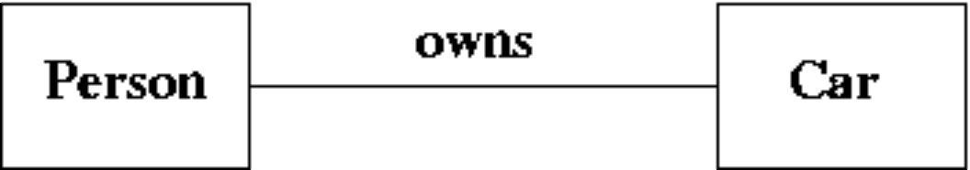
  a. | Take the primary key from person and add it to the car relation as a foreign key.
  b. | Take the primary key from car and add it to the person relation as a foreign key.
  c. | Subsume one of the relations into the other.
  d. | All of the above will work.
  e. | Take the primary key from both car and person and put them into a new relation called "owns".
Mark: (1)
18. | The external view of the ANSI-SPARC architecture chiefly concerns:
  a. | the way the data is actually stored
  b. | the formal description of the data
  c. | the way individual users see the data
  d. | the data that users outside the company are permitted to view
  e. | the interface to other applications
Mark: (1)

19. | ER Scenario  The scenario described here is that of a book library. Books in the library can be borrowed by a borrower, and a complete history of all the books a borrower has borrowed is held in the BorrowHistory entity set. All books must have an author.  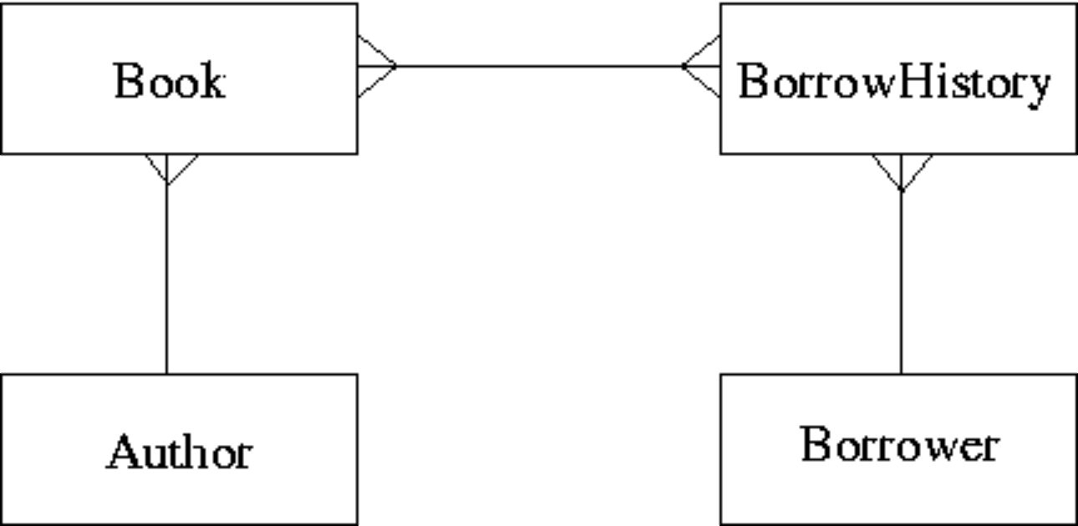  The attributes of each entity set are listed below:  Author(name,country)  Book(title,publisher)  BorrowHistory(when-borrowed,when-due-back)  Borrower(name,address,date-of-birth)  ER Scenario 1 is a good example of:
  a. | A Tsunami
  b. | A Chasm Trap
  c. | A Fan Trap
  d. | A Cliff Trap
  e. | None of the above
Mark: (1)

20. | Select the term which best describes the cardinality of the relationship between the table job to the table requirement.
    job
    reference | employer | salary
    01 | Napier | £20000
    02 | GCHQ | £22000
    03 | Napier | £24000
    requirement
    job | skill
    01 | Unix Admin
    01 | Oracle Admin
    02 | Unix Admin
    02 | Number Theory
  a. | some to many
  b. | one to one
  c. | one to many
  d. | many to many
  e. | many to one
Mark: (1)
21. | Which of the following is part of the ANSI/SPARC three level architecture model.
  a. | conceptual
  b. | client
  c. | contextual
  d. | contactable
  e. | coaxial
Mark: (1)

22. | Given the following transaction schedule:  Which of the following precedence graphs depicts the above scerario?
  time | TRANSACTION 1 | TRANSACTION 2 | TRANSACTION 3
  t1 | read(A)
  t2 |  | read(B) | read(B)
  t3 | read(B)
  t4 |  | write(C)
  t5 |  |  | write(B)
  t6 |  |  | read(A)
  t7 |  |  | write(A)
  t8 | write(A)
  t9 | write(C)
  a. | 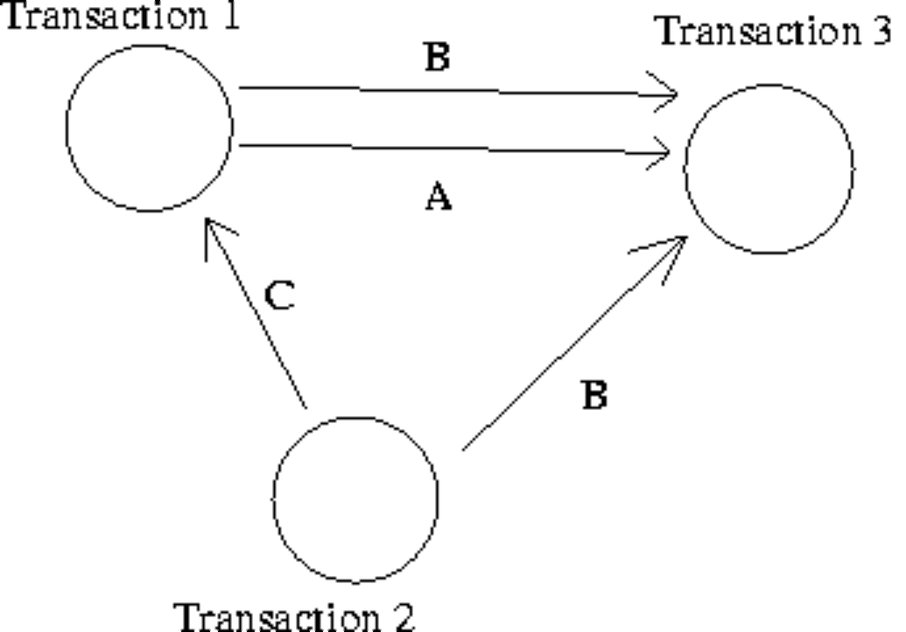
  b. | 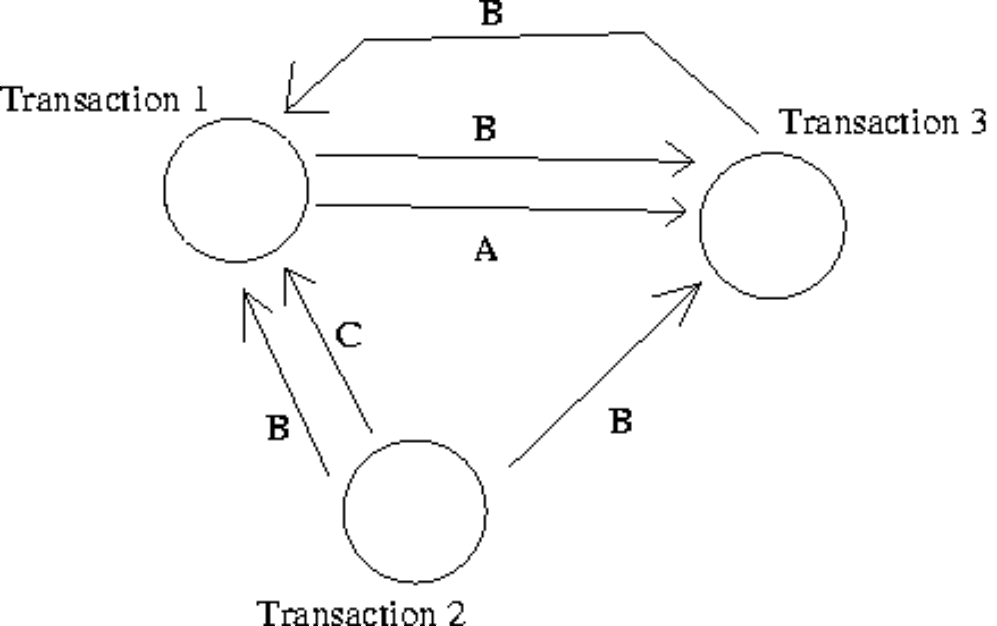
  c. | 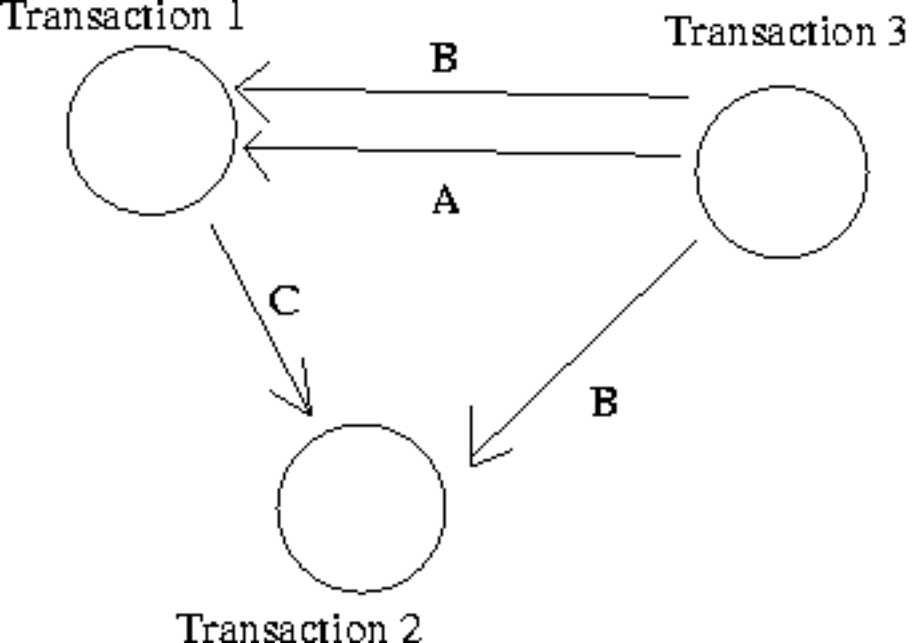
  d. | 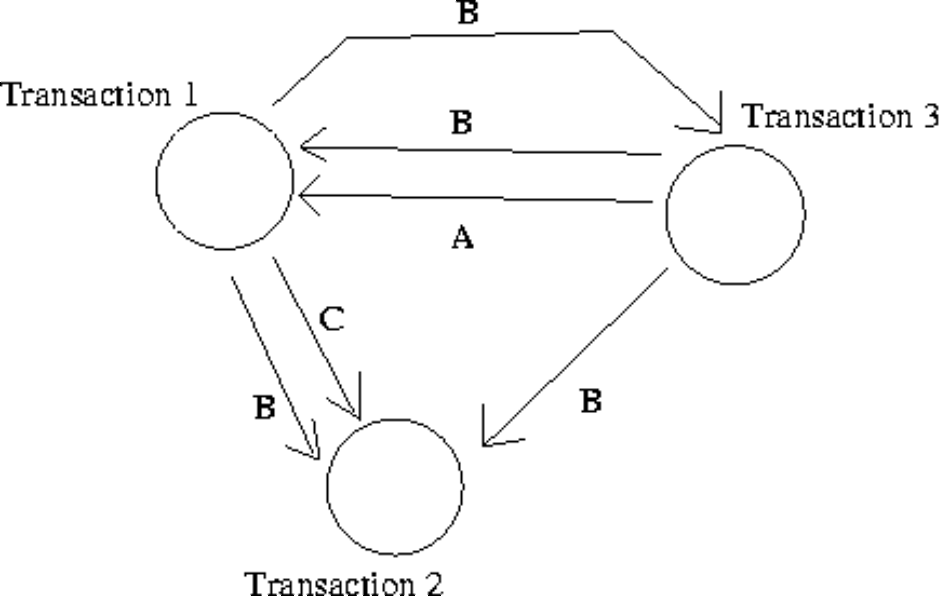
  e. | None of the above.
Mark: (1)
23. | Which of the following is NOT one of the ACID properties of transactions.
  a. | Atomic
  b. | Durable
  c. | Consistency preserving
  d. | Isomorphic
  e. | All of the above are properties of ACID.
Mark: (1)

24. | 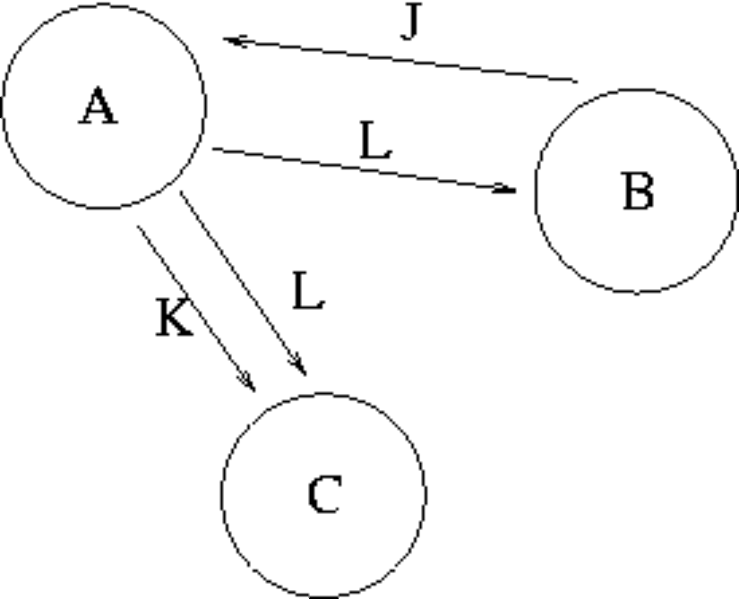  The graph in the Transaction Scenario was produced from the following schedule. time  Compare the precedence graph to the transaction schedule, and select the TRUE statement from the following:
  time | Transaction A | Transaction B | Transaction C
  1 |  | WRITE(J)
  2 | READ(J)
  3 | WRITE(K)
  4 |  |  | READ(K)
  5 | WRITE(L)
  6 |  | READ(L)
  7 |  |  | READ(L)
  8 | COMMIT
  9 |  | COMMIT
  10 |  |  | COMMIT
  a. | The precedence graph is accurately drawn
  b. | The circles should contain the attributes, and the loops labeled with the transaction names.
  c. | One or more of the loops are missing
  d. | One or more of the arrows are pointing the wrong way
  e. | Errors in BOTH loops and arrow direction
Mark: (1)

25. | Using DEFERRED UPDATE, modifications made by a transaction which has not yet aborted or committed
  a. | are applied in the same way as in IMMEDIATE UPDATE.
  b. | are applied to the log file and then the disk
  c. | are applied only to the disk
  d. | are applied only to the log file
  e. | None of the above
Mark: (1)

26. | A database includes two relations S and P  The result of the natural join of S and P is:
  S | P
    Matric_No | F_Name | L_Name | Prog_Code
    04009991 | Alicia | Smith | 0001
    04009992 | Alan | Smith | 0002
    04009993 | John | Bush | NULL
    Prog_Code | P_Name
    0001 | Computing
    0002 | Soft. Eng.
  a.
    Matric_No | F_Name | L_Name | Prog_Code | Prog_Code | P_Name
    04009991 | Alicia | Smith | 0001 | 0001 | Computing
    04009991 | Alicia | Smith | 0001 | 0002 | Soft. Eng.
    04009992 | Alan | Smith | 0002 | 0001 | Computing
    04009992 | Alan | Smith | 0002 | 0002 | Soft. Eng.
    04009993 | John | Bush | NULL | NULL | NULL
    04009993 | John | Bush | NULL | NULL | NULL
  b.
    Matric_No | F_Name | L_Name | Prog_Code | P_Name
    04009991 | Alicia | Smith | 0001 | Computing
    04009992 | Alan | Smith | 0002 | Soft. Eng.
  c.
    Matric_No | F_Name | L_Name | Prog_Code | P_Name
    04009991 | Alicia | Smith | 0001 | Computing
    04009992 | Alan | Smith | 0002 | Soft. Eng.
    04009993 | John | Bush | NULL | NULL
  d.
    Matric_No | F_Name | L_Name | Prog_Code | Prog_Code | P_Name
    04009991 | Alicia | Smith | 0001 | 0001 | Computing
    04009991 | Alicia | Smith | 0001 | 0002 | Soft. Eng.
    04009992 | Alan | Smith | 0002 | 0001 | Computing
    04009992 | Alan | Smith | 0002 | 0002 | Soft. Eng.
    04009993 | John | Bush | NULL | 0001 | Computing
    04009993 | John | Bush | NULL | 0002 | Soft. Eng.
  e. | None of the above
Mark: (1)

27. | Relation C is the join of relation A and relation B on condition p. Which of the following statements must be true in all cases?
  a. | The arity of C is greater than the arity of A
  b. | The cardinality of C is less than the cardinality of A
  c. | The arity of C is less than the arity of A
  d. | The cardinality of C is greater than the cardinality of A
  e. | None of the above
Mark: (1)
28. | The option of dropping a secondary index to a table is being considered. Which of the following is most likely to be a consequence of dropping the index?
  a. | Certain insertions may be faster
  b. | Certain seek operations may be faster.
  c. | Certain updates may be slower
  d. | More disk space may be required
  e. | Certain foreign key relations may not be maintained
Mark: (1)
29. | Which of the following is TRUE concerning TRANSFER TIME for hard drives.
  a. | Transfer time is measured in Mbytes.
  b. | Seek time is greater than transfer time.
  c. | Depends on the number of files being transferred.
  d. | Is the time to move data from the disk surface to the hard drive.
  e. | Must be measured as a ratio of seek time.
Mark: (1)

30. | With respect to the B+ tree index method, select the TRUE statement:
  a. | Only the primary key field may have a B+ tree index.
  b. | Records are physically stored in primary key order.
  c. | B+ trees use a hashing algorithm.
  d. | The index tree may become unbalanced as a result of updates.
  e. | None of the above.
Mark: (1)
31. | Select the TRUE statement.
  a. | SQL cursors indicate the next line of code to be executed in a C++ program.
  b. | SQL is embedded within a C++ program to increase the speed of the C++ program.
  c. | SQL is embedded to make C++ programs more efficient.
  d. | SQL embedded in C++ provides facilities to extract data from a database.
  e. | SQL is embedded within C++ to handle sequential file processing.
Mark: (1)
32. | A PHP script is required to return the number of rows in the table X. Two approaches are being considered:  T1 A cursor based on the SQL statement  "SELECT * FROM X" should be used.  T2 A cursor based on the SQL statement  "SELECT COUNT(*) FROM X" should be used.
  a. | T2 is feasible, T1 is not feasible.
  b. | T1 and T2 are feasible however T2 is better.
  c. | T1 and T2 are feasible however T1 is better.
  d. | T1 is feasible, T2 is not feasible.
  e. | Neither T1 nor T2 are feasible
Mark: (1)

33. | Which of the following is a type of lock which cannot be obtained in Oracle.
  a. | Insert lock
  b. | Read lock
  c. | Exclusive Lock
  d. | Shared Lock
  e. | Write Lock
Mark: (1)
34. | Which one of the following techniques is sometimes used to solve integrity problems in a concurrent transaction scenario?
  a. | Greedy algorithms.
  b. | First-come first-served.
  c. | First-fit.
  d. | Strassens's algorithm.
  e. | Two-phase locking.
Mark: (1)
35. | A timetable database is required for a University Department. Each taught event is part of a module, each event will have exactly one member of staff associated and several individual students. Each event takes place in a single weekly time slot. Each time slot has a day of the week and a time of day associated. Staff and students can have more than one event to attend.  Which of the following is the best approach to implementing the students that attend relationship using a relational database system?
  a. | A repeating field attends is included as part of the student table
  b. | A table attends contains an event/student pair for every instance of a student attending an event
  c. | A repeating field attends is included as part of the event table
  d. | A secondary attends key is added to the event table
  e. | None of the above
Mark: (1)
36. | When producing relations for the diagram shown, where almost all P entities relate to a Q entity:  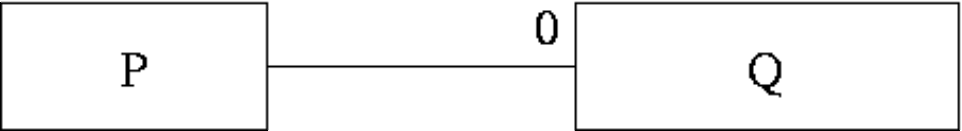  Which of the following is usually best?
  a. | Q should be subsumed into P.
  b. | Have an intermediate table containing the primary keys from both P and Q.
  c. | This cannot be mapped into relations.
  d. | P should be subsumed into Q.
  e. | it is best to keep P and Q as separate relations.
Mark: (1)
37. | When mapping ER models into relations, which of the following is NOT true?
  a. | Each individual entity is mapped into a row of the corresponding relation.
  b. | Each 1-m relationship is mapped into a new relation.
  c. | Each m-n relationship is mapped into a new relation.
  d. | Each attribute is mapped into a column of the corresponding relation.
  e. | Each entity type is mapped into a relation.
Mark: (1)
38. | In a relation, an instance is stored as
  a. | A Row
  b. | As an index
  c. | As a Many to many relationship
  d. | A Column
  e. | An Attribute
Mark: (1)

39. | Aborting a transaction
  a. | Results in deadlock
  b. | Deletes the database for security reasons
  c. | Is only possible in Microsoft Access
  d. | Removes changes made in a transaction after it has committed.
  e. | Removes changes made so far in the current transaction.
Mark: (1)
40. | During Rollforward, which of the following is NOT true
  a. | Transactions which are in the log but not yet committed are restarted where they left off.
  b. | Transactions which are reapplied are reapplied to the image as it was since the last checkpoint.
  c. | Only once the rollforward has been completed can new transactions be performed.
  d. | Committed transactions in the log are reapplied.
  e. | Committed transactions are reapplied in the same order as they appear in the log.
Mark: (1)
Total Marks [40]

End of Paper

