Matric No:
NAPIER UNIVERSITY
SCHOOL OF COMPUTING
CO22001
Database Systems
ACADEMIC SESSION: 2004-05
EXAMINATION DIET: JANUARY
TRIMESTER: ONE
EXAM DURATION: 2 HOURS
READING TIME: NONE
EXAM PAPER INFORMATION
Answer ALL questions.
Answers must be inserted on the EDPAC answer sheet provided using an HB pencil.

For full instructions see next page.
Select ONE from (a) to (e)
Number of pages – TWENTY-TWO
Number of questions – FORTY
Number of sections – ONE
EXAMINERS: John Old, Ken Chisholm, Gordon Russell, Jessie Kennedy

PLEASE READ THE FULL INSTRUCTIONS BEFORE COMMENCING WRITING

Instructions to Candidates -
Write the following details in the top of the Candidate Name section in this order:

Your surname
Your Initials

In the machine readable part of the name section, make a horizontal mark between the two brackets on the letter of your choice to enter the following details in machine readable form in this order:

Your surname
Your initials

e.g. [R] [U] [S] [S] [E] [L] [L] [G]

In the box named Candidate Number mark in your matriculation number.

In the box named Subject Code, mark in 001

Leave the subject box blank.

At the end of the test, return your answer sheet to the invigilator.

Attempt all of the following questions. The test consists of 40 multiple choice questions.

All the questions offer five options. For each you are required to indicate which you consider the single most appropriate answer. Indicate your selection by making a mark in the row on the answer sheet corresponding to the question number. Use an HB pencil and make a mark the width of the column (A - E), which corresponds to your chosen answer. To change an answer put the mark in the new column and circle the correction.

1. | If a system can enforce referential integrity, then this ensures that
  a. | a record is always referred to from another record
  b. | a foreign key attribute in a record always refers to another record which does not contain nulls
  c. | a record can never contain a null value for a foreign key attribute.
  d. | a non-null foreign key attribute always refers to another record
  e. | a foreign key attribute in a record always refers to another record which contains nulls
Mark: (1)
2. | Consider the following functional dependencies  Which of the following relational schemas might be the result of normalising R(a,b,c,d)?
  a,b | => | c,d |  | e,g,h | => | f,j
  a,c | => | b,d |  | p,q | => | r,s
  e,f,g | => | h,i |  | s | => | t
  f,g | => | j |  | q | => | u
  g,h | => | i
  a. | The schema R1(a,b) R2(b,c) R3(c,d)
  b. | The schema R1(a,b,c) R2(a,b,d)
  c. | The schema R1(a,b) R2(a,c) R3(b,d)
  d. | The schema R(a,b,c,d)
  e. | The schema R1(a,b) R2(a,c) R3(a,d)
Mark: (1)

3. | Given the following relational schema and functional dependences, decide which normal form the relation R is in:  R(a,b,c,d,e)  a,b -> c,d,e  d,b,c -> a  e,b,c -> d,a  c,d -> e
  a. | Unnormalised
  b. | 1NF
  c. | 2NF
  d. | 3NF
  e. | BCNF
Mark: (1)
4. | Which normalisation transformation corresponds to "Eliminating partial key dependencies"?
  a. | unnormalised to 1NF
  b. | 1NF to 2NF
  c. | 2NF to 3NF
  d. | 3NF to BCNF
  e. | None of the above
Mark: (1)
5. | Consider the relational schema R(A,B,C,D,E) with non-key functional dependencies C,D -> E and B -> C.  Select the strongest statement that can be made about the schema R
  a. | R is in BCNF normal form
  b. | R is in second normal form
  c. | R is in first normal form
  d. | R is in third normal form
  e. | None of the above

Mark: (1)
6. | Select the TRUE statement which would indicate data in the database as "redundant".
  a. | The data has not yet been COMMITTED to the database
  b. | It is unique in the database
  c. | Secondary keys are not unique
  d. | A VIEW has the same data as a TABLE.
  e. | It can be derived from other data in the database.
Mark: (1)
7. | Given the following relational database schema:  Customer(custno,name,address,telno,credit_rating)  Order(orderno,custno,data,delivery_date,total)  The following query is not well-formed SQL. Which of the following describes the main problem with the query.  select custno,name  from order,customer  where customer.custno = order.orderno and  delivery_date = '01-Jan-2001';
  a. | The keywords are in lower case
  b. | The date is incorrectly formatted
  c. | The join condition is wrong
  d. | The tables are in the wrong order
  e. | None of the above
Mark: (1)

8. | Using the scenario above, what is a suitable primary key of the table Workfor?
    Departments
    DepNo | Depname
    1 | Computng
    2 | Electrical
    3 | Geography
    4 | History
    5 | Business
    Employees
    Empno | Empname
    1 | Gordon
    1 | Ken
    1 | Brian
    1 | Colin
    1 | George
    WorkFor
    Empno | Depno
    1 | 1
    3 | 2
    4 | 1
    3 | 3
    1 | 2
    2 | 5
  a. | it does not have a primary key
  b. | depno
  c. | empno
  d. | a composite key of depno and empno
  e. | the many-to-many relationship must be eliminated before it can be calculated.
Mark: (1)
9. | Continuing from the previous question  Using the scenario above, what is the CARDINALITY of the table "WorkFor"?
  a. | 2
  b. | 6
  c. | 3
  d. | 12
  e. | none of the above.
Mark: (1)

10. | Given a database:  Customer(Cust_no,Name,Address)  Order(Order_no,Cust_no,C_Date,Completed)  Make(Order_no,Maker_no,Dress_style,Colour)  Identify the SQL command which will return the customer's name and address for all orders that have been made or are being made from Red coloured materials.
  a. | SELECT Name,Address  FROM Customer,Make  WHERE Colour = 'Red'
  b. | SELECT Name,Address  FROM Customer,Order,Make  WHERE Colour = 'Red'  AND Customer.Cust_no = Order.Cust_no  AND Completed in ('Y','N')
  c. | SELECT Name,Address  FROM Customer,Order,Make  WHERE Colour = 'Red'  AND Customer.Cust_no = Order.Cust_no
  d. | SELECT Name,Address  FROM Customer,Order,Make  WHERE Customer.Cust_no = Order.Cust_no  AND Colour = 'Red'  AND Order.Order_no = Make.Order_no
  e. | None of the above
Mark: (1)
11. | Which of the following best describes the internal level of the ANSI/SPARC three level architecture?
  a. | The internal level is concerned with the how stored fields are represented and which indices exist.
  b. | The internal level provides a conceptual view of the data structure.
  c. | The internal level is concerned with the data as seen by individuals internal to the enterprise.
  d. | The internal level is concerned with the users' view of the data.
  e. | The internal level is concerned with the layout of records and their locations within disk blocks.
Mark: (1)
12. | The Data Dictionary provides which of the following features.
  a. | Costings for future database changes.
  b. | Support for the SQL interface to the database.
  c. | Transaction deadlock detection.
  d. | Support for backup procedures.
  e. | None of the above.
Mark: (1)
13. | At the Physical design stage, select the TRUE statement.
  a. | ER diagrams are mapped into relations
  b. | Relationships are mapped into tables
  c. | ER diagrams are mapped into relationships
  d. | Indices are identified and implemented for tables
  e. | ER diagrams are mapped into tables.
Mark: (1)
14. | Within EER diagram techniques, which of the following could be the result of Generalising  superclass - card(cardnumber, issuer, cardholder)  subclass - visa(expiryDate, creditLimit)  subclass - switch(issueDate, colour)
  a. | subclass - card(cardnumber, issuer, cardholder)  superclass - visa(expiryDate, creditLimit)  superclass - switch(issueDate, colour)
  b. | card(cardnumber, issuer, cardholder, expiryDate,  creditLimit, issueDate, colour)
  c. | superclass - card(cardnumber, issuer, cardholder)  subclass - visa(expiryDate, creditLimit)  subclass - switch(issueDate, colour)
  d. | superclass - card(cardnumber, issuer, cardholder)  subclass - visa(expiryDate, creditLimit)  subclass - switch(expiryDate, issueDate, colour)
  e. | subclass - card(cardnumber, issuer, cardholder)  subclass - visa(expiryDate, creditLimit)  subclass - switch(issueDate, colour)
Mark: (1)

15. | The relationship between two entity types A and B is 1:1, and the relationship is optional at the A end. Only 50% of B entities are related to an A entity. Now consider mapping these entity types into relations. Select the best statement from the following list:
  a. | A and B should be kept separate with the foreign key in the B relation.
  b. | B should be subsumed by A
  c. | A and B should be kept separate with a foreign key in both A and B.
  d. | A and B should be kept separate with the foreign key in the A relation.
  e. | A should be subsumed by B
Mark: (1)
16. | In Enhanced ER diagrams, a subclass
  a. | Is part of Chun's notation.
  b. | is contained in one superclass.
  c. | may contain many superclasses.
  d. | can only exist in Chen's notation.
  e. | may contain only one superclass.
Mark: (1)
17. | The external view of the ANSI-SPARC architecture chiefly concerns:
  a. | the way the data is actually stored
  b. | the way individual users see the data
  c. | the formal description of the data
  d. | the data that users outside the company are permitted to view
  e. | the interface to other applications
Mark: (1)

18. | Which of the following is offered through the use of EER (Enhanced ER) Modelling?
  a. | Many to many relation
  b. | Partial participation
  c. | Canonisation
  d. | Specialisation
  e. | Confirmation
Mark: (1)

19. | A timetable database is required for a University Department. Each taught event is part of a module, each event will have exactly one member of staff associated and several individual students. Each event takes place in a single weekly time slot. Each time slot has a day of the week and a time of day associated. Staff and students can have more than one event to attend.  Select the most appropriate ER diagram for the above scenario:
  a. | 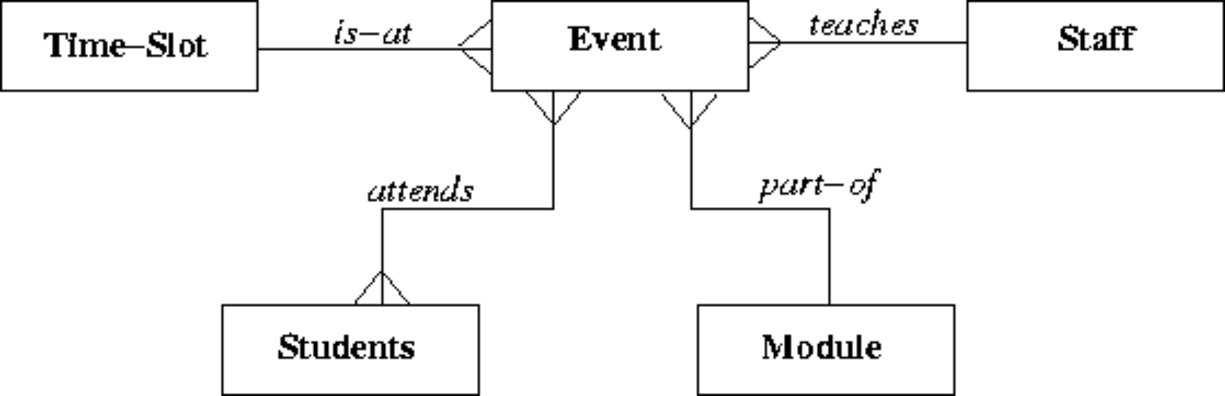
  b. | 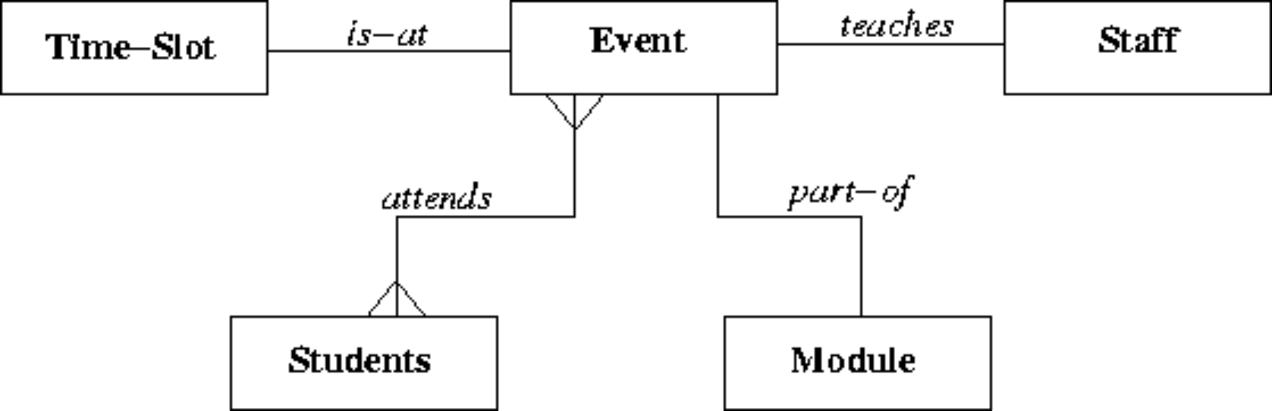
  c. | 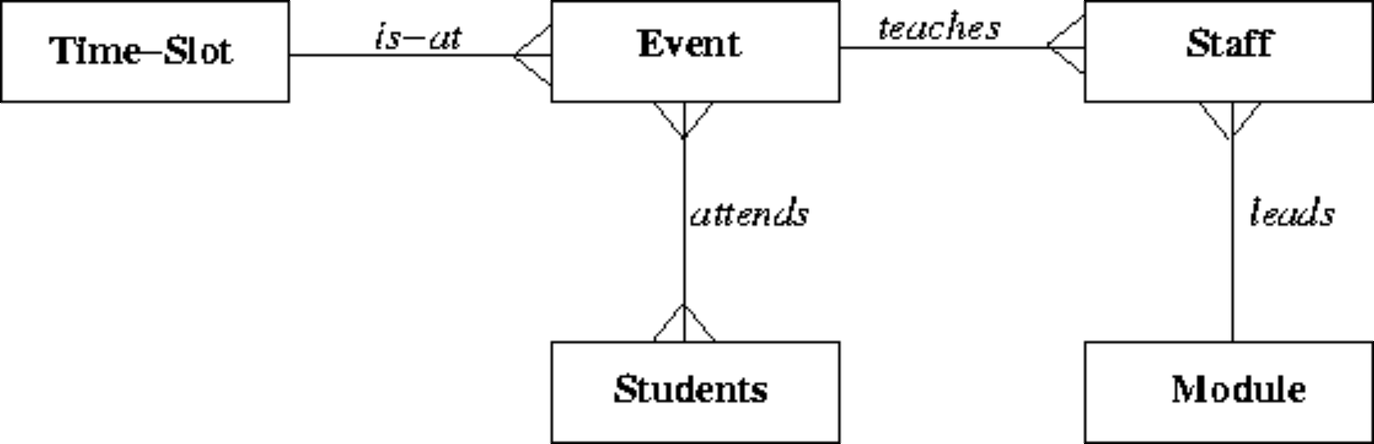
  d. | 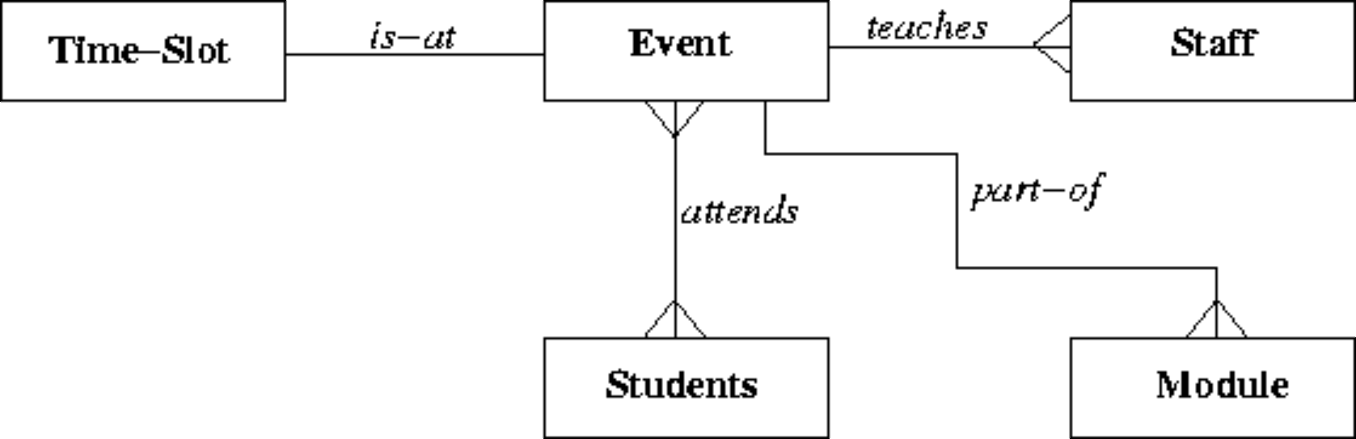
  e. | 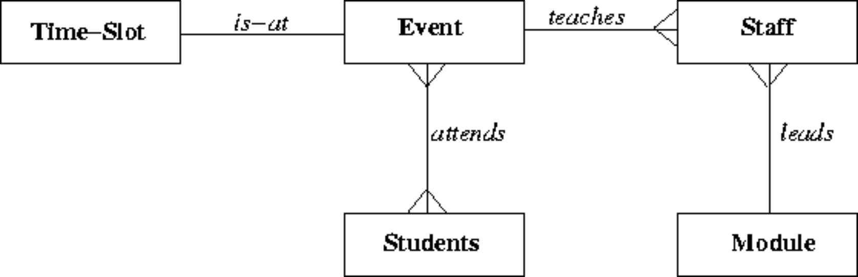
Mark: (1)
20. | Which of the following is part of the ANSI/SPARC three level architecture model.
  a. | contactable
  b. | contextual
  c. | client
  d. | coaxial
  e. | conceptual
Mark: (1)
21. | Given the following portion of an ER diagram with a 1:n relationship which of the following is the correct rule for mapping it in to a relational schema?  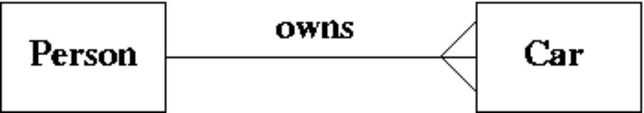
  a. | Take the primary key from person and add it to the car relation as a foreign key.
  b. | Take the primary key from car and add it to the person relation as a foreign key.
  c. | Subsume one of the relations into the other.
  d. | All of the above will work.
  e. | Take the primary key from both car and person and put them into a new relation called "owns".
Mark: (1)
22. | Which of the following is a good example of what is meant by serialisability.
  a. | The situation where the Lost Update problem exists.
  b. | The result of the transactions is the same as if the transactions went one after another.
  c. | All transactions happen one after another.
  d. | All disk access happens one after another.
  e. | The situation where a cascade abort occurs.
Mark: (1)

23. | Transactions are described as supporting the ACID model. What does the "C" stand for in ACID?
  a. | Consistency preservation
  b. | Correctness
  c. | Completeness
  d. | Concurrency control
  e. | Computation
Mark: (1)
24. | In an DBMS without concurrency control, what consistency problem does the following transaction schedule depict?
  Time | Transaction A | Transaction B
  t1 | read R
  t2 |  | read R
  t3 | write R
  t4 |  | write R
  a. | Uncommitted Dependency
  b. | Deadlock
  c. | Inconsistent Analysis
  d. | Dirty Read
  e. | Lost Update
Mark: (1)
25. | Which one of the following problems can occur due to introducing locks in a concurrent transaction scenario?
  a. | Information overwrite
  b. | Deadlock
  c. | Lack of integrity
  d. | Loss of information
  e. | None of the above
Mark: (1)
26. | Consider the relations P and Q above. The number of rows in the unconditional join, or Cartesian product of P and Q is
    Relation P
    ColW | ColX
    A | 4
    B | 5
    C | 6
    Relation Q
    ColY | ColZ
    B | 7
    D | 4
    C | 6
  a. | 8
  b. | 9
  c. | 4
  d. | 6
  e. | None of the above.
Mark: (1)

27. | A database includes two relations S and P  The result of the natural join of S and P is:
  S | P
    Matric_No | F_Name | L_Name | Prog_Code
    04009991 | Alicia | Smith | 0001
    04009992 | Alan | Smith | 0002
    04009993 | John | Bush | NULL
    Prog_Code | P_Name
    0001 | Computing
    0002 | Soft. Eng.
  a.
    Matric_No | F_Name | L_Name | Prog_Code | Prog_Code | P_Name
    04009991 | Alicia | Smith | 0001 | 0001 | Computing
    04009991 | Alicia | Smith | 0001 | 0002 | Soft. Eng.
    04009992 | Alan | Smith | 0002 | 0001 | Computing
    04009992 | Alan | Smith | 0002 | 0002 | Soft. Eng.
    04009993 | John | Bush | NULL | NULL | NULL
    04009993 | John | Bush | NULL | NULL | NULL
  b.
    Matric_No | F_Name | L_Name | Prog_Code | Prog_Code | P_Name
    04009991 | Alicia | Smith | 0001 | 0001 | Computing
    04009991 | Alicia | Smith | 0001 | 0002 | Soft. Eng.
    04009992 | Alan | Smith | 0002 | 0001 | Computing
    04009992 | Alan | Smith | 0002 | 0002 | Soft. Eng.
    04009993 | John | Bush | NULL | 0001 | Computing
    04009993 | John | Bush | NULL | 0002 | Soft. Eng.
  c.
    Matric_No | F_Name | L_Name | Prog_Code | P_Name
    04009991 | Alicia | Smith | 0001 | Computing
    04009992 | Alan | Smith | 0002 | Soft. Eng.
  d.
    Matric_No | F_Name | L_Name | Prog_Code | P_Name
    04009991 | Alicia | Smith | 0001 | Computing
    04009992 | Alan | Smith | 0002 | Soft. Eng.
    04009993 | John | Bush | NULL | NULL
  e. | None of the above
Mark: (1)

28. | Consider each of the following properties of an index which uses ordered trees. Select the feature which characterises POOR performance.
  a. | The tree contains long branches
  b. | The branching factor is high
  c. | The maximum depth of the index tree is small
  d. | The attributes being indexed are short
  e. | The index tree is balanced
Mark: (1)
29. | Consider a table where records are stored in primary key order. Select the statement that best describes the cost of the operations: insert, delete and seek. Deleted records are NOT "Flagged".
  a. | Insert and delete are expensive, seek is cheap.
  b. | Insert, delete and seek are all cheap.
  c. | Insert is expensive, delete and seek are cheap.
  d. | Insert, delete and seek are all expensive.
  e. | Insert and delete are cheap, seek is expensive.
Mark: (1)
30. | Indexes speed up data access. Select the TRUE statement:
  a. | Primary indexes may have null values.
  b. | Primary indexes can have duplicate keys.
  c. | Secondary indexes must have unique keys.
  d. | Columns which are frequently modified are good candidates for indexing.
  e. | None of the above.
Mark: (1)

31. | The purpose of Embedded SQL is to allow
  a. | SQL queries to be executed as part of a programming language.
  b. | Programming language to be embedded in SQL
  c. | Databases to be embedded in SQL
  d. | Programs to be embedded in a database.
  e. | None of the above
Mark: (1)
32. | Select the TRUE statement.
  a. | SQL is embedded to make C++ programs more efficient.
  b. | SQL cursors indicate the next line of code to be executed in a C++ program.
  c. | SQL is embedded within a C++ program to increase the speed of the C++ program.
  d. | SQL embedded in C++ provides facilities to extract data from a database.
  e. | SQL is embedded within C++ to handle sequential file processing.
Mark: (1)
33. | With respect to Two-Phase Locking, select the TRUE statement.
  a. | If a needed lock cannot be acquired then the transactions are deadlocked
  b. | Before accessing an item a lock must first be acquired
  c. | Locks are only required when accessing keys
  d. | Locks can be acquired at any point in a transaction
  e. | None of the above
Mark: (1)

34. | Locking can be fine grained or coarse grained. Select the TRUE statement.
  a. | Fine grained locking is cheaper to implement.
  b. | Only fine grained locking results in enforcing serializability.
  c. | Fine grained locking is more expensive to implement.
  d. | Course grained locking improves parallelism.
  e. | Only course grained locking results in enforcing serializability.
Mark: (1)

35. | 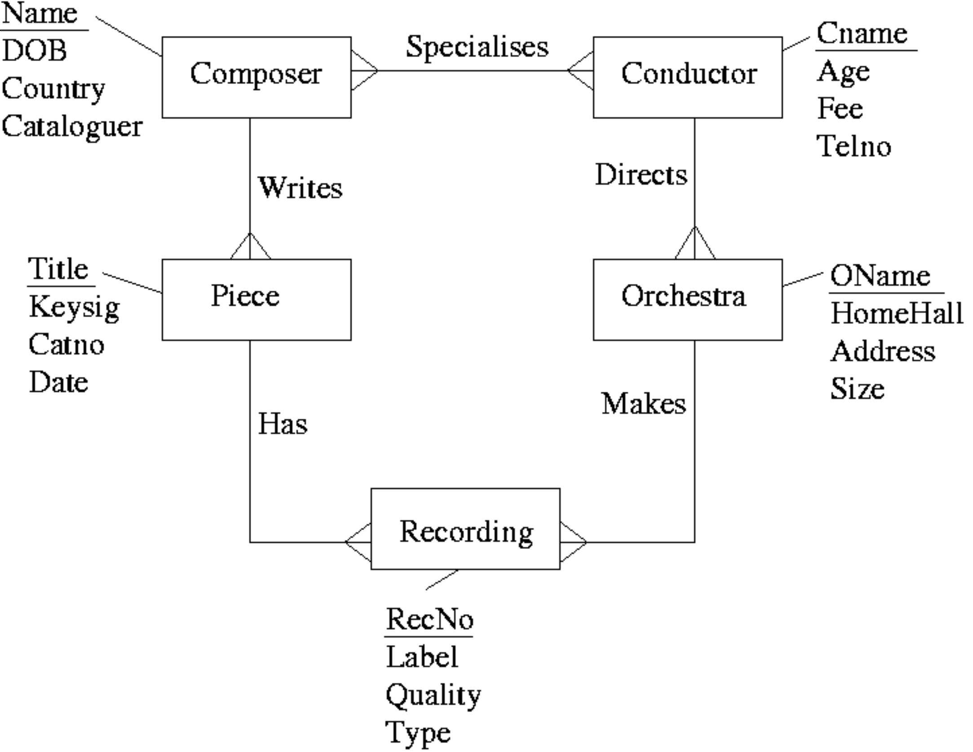  After mapping the above ERD to a relational schema which of the following set of relations would be obtained?
  a. | Composer(Name, DOB, Country, Cataloguer, Cname)  Conductor(Cname, Age, Fee, TelNo, Name)  Piece(Title, KeySig, CatNo, Date, Name)  Orchestra(OName, HomeHall, Adress, Size, Cname)  Recording(RecNo, Label, Quality, Type, Title, OName)
  b. | Composer(Name, DOB, Country, Cataloguer)  Conductor(Cname, Age, Fee, TelNo, OName)  Piece(Title, KeySig, CatNo, Date, Name)  Orchestra(OName, HomeHall, Adress, Size)  Recording(RecNo, Label, Quality, Type, Title, OName)  Specialises(Name, Cname)
  c. | Composer(Name, DOB, Country, Cataloguer)  Conductor(Cname, Age, Fee, TelNo)  Piece(Title, KeySig, CatNo, Date, Name)  Orchestra(OName, HomeHall, Adress, Size, Cname)  Recording(RecNo, Label, Quality, Type, Title, OName)  Specialises(Name, Cname)
  d. | Composer(Name, DOB, Country, Cataloguer)  Conductor(Cname, Age, Fee, TelNo)  Piece(Title, KeySig, CatNo, Date, Name, RecNo)  Orchestra(OName, HomeHall, Adress, Size, Cname, RecNo)  Recording(RecNo, Label, Quality, Type)  Specialises(Name, Cname)
  e. | None of the above.
Mark: (1)

36. | A number of vats of chemical are monitored by an automatic system. Temperature and pressure readings are recorded for each vat at regular intervals.  Currently there are 3 vats. The current procedure is to take readings 4 times a day at 01:00, 07:00 13:00 and 19:00.  Each of the following schemes are being considered for storing data:  A  Temperature(theDate, vat1_0100, vat1_0700, vat1_1300, vat1_1900, vat2_0100, vat2_0700, vat2_1300, vat2_1900, vat3_0100, vat3_0700, vat3_1300, vat3_1900)  Pressure(theDate, vat1_0100, vat1_0700, vat1_1300, vat1_1900, vat2_0100, vat2_0700, vat2_1300, vat2_1900, vat3_0100, vat3_0700, vat3_1300, vat3_1900)  B  Temperature(theDate, time, vat, value)  Pressure(theDate, time, vat, value)  The average pressure in vat 1 for the period 2 Feb 2003 to 5 Feb 2003 is required. The following SQL statement is an attempt at calculating this value based on schema A:  SELECT SUM(vat1_0100+vat1_0700+vat1_1300+vat1_1900)/16  FROM pressure  WHERE theDate BETWEEN '2 Feb 2003' AND '5 Feb 2003'  Given that the reading for 3 Feb at 0700 is null, but that all other values are correct; select the statement that best describes the outcome:
  a. | All values for 3 Feb are discarded, the remaining 12 values are summed and divided by 16
  b. | The 15 correct values are added - but then erroneously divided by 16
  c. | The 15 correct values are added - and then correctly divided by 15
  d. | The null value propogates and zero rows are returned
  e. | The null value propogates and a row with the value null is returned
Mark: (1)

37. | Two entity types A and B are related by a 1:1 relationship which is optional at both ends. In the process of implementing A and B as relations you would
  a. | Combine A and B together into a single relation.
  b. | Keep them separate and put a foreign key in one of A or B.
  c. | Combine A and B together into a single relationship.
  d. | Use a primary key which is a composition of the primary keys of A and B.
  e. | Keep them separate and put a foreign key in both A and B.
Mark: (1)
38. | Select the TRUE statement.
  a. | For referential integrity, all foreign keys should equal a primary key in another table.
  b. | For referential integrity, each foreign key should be null or equal to a primary key in another table.
  c. | For entity integrity, all primary keys should be null or unique.
  d. | For referential integrity, all primary keys should be non null.
  e. | For entity integrity, all foreign keys should be null.
Mark: (1)
39. | With Immediate Update, writing to an attribute results in the DBMS
  a. | Immediately performing a COMMIT.
  b. | Writing the old and new attribute value to the log.
  c. | Writing the new value to the log.
  d. | Immediately writing the change to the database stored on disk.
  e. | Releasing concomitant locks.
Mark: (1)

40. | Aborting a transaction
  a. | Results in deadlock
  b. | Deletes the database for security reasons
  c. | Removes changes made in a transaction after it has committed.
  d. | Removes changes made so far in the current transaction.
  e. | Is only possible in Microsoft Access
Mark: (1)
Total Marks [40]

End of Paper

